Making and using keys

Using a key - following the trail with buttercups (see booklet, page 26)
Pupil Sheet

Buttercup fact file (see booklet, page 26)

- How many sepals are there?…….................. How many petals are there?..............................................
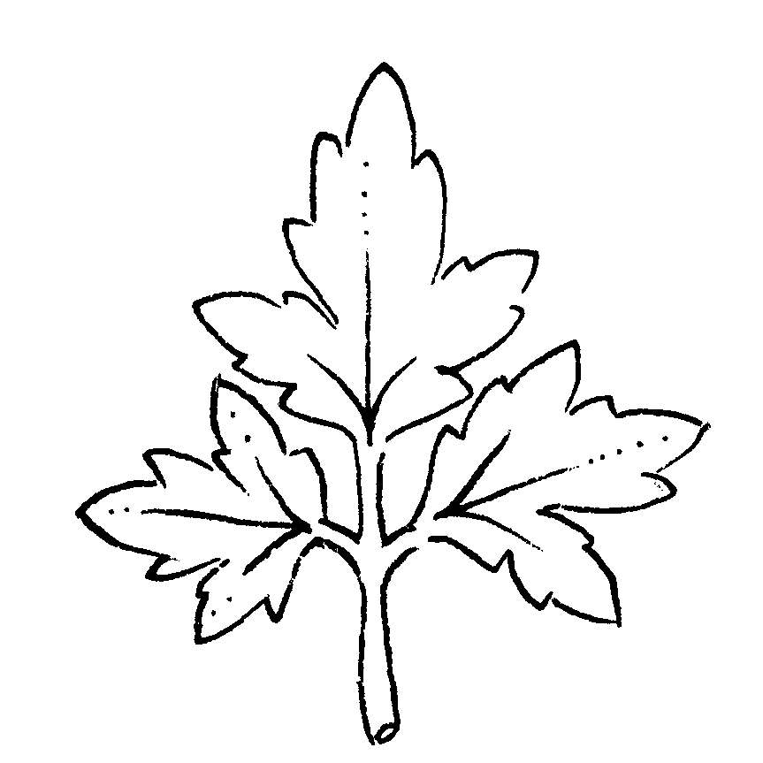
leaflet
- Are the leaf blades divided up
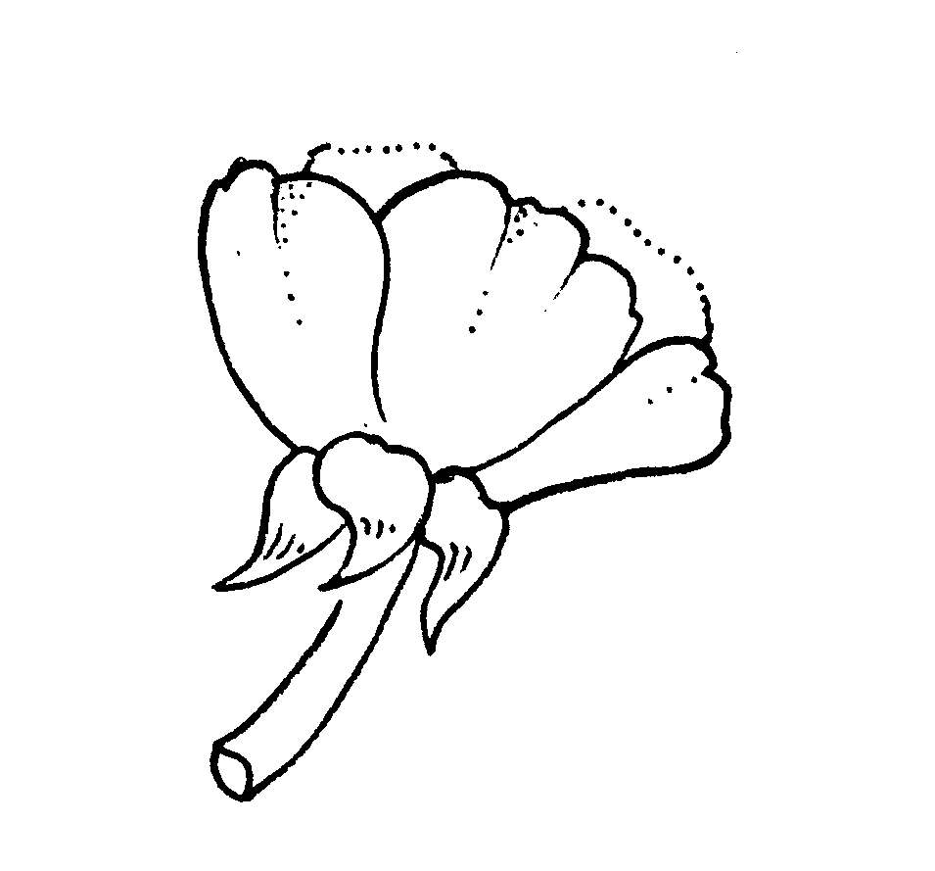
into smaller leaflets or deeply lobed? ............................................................

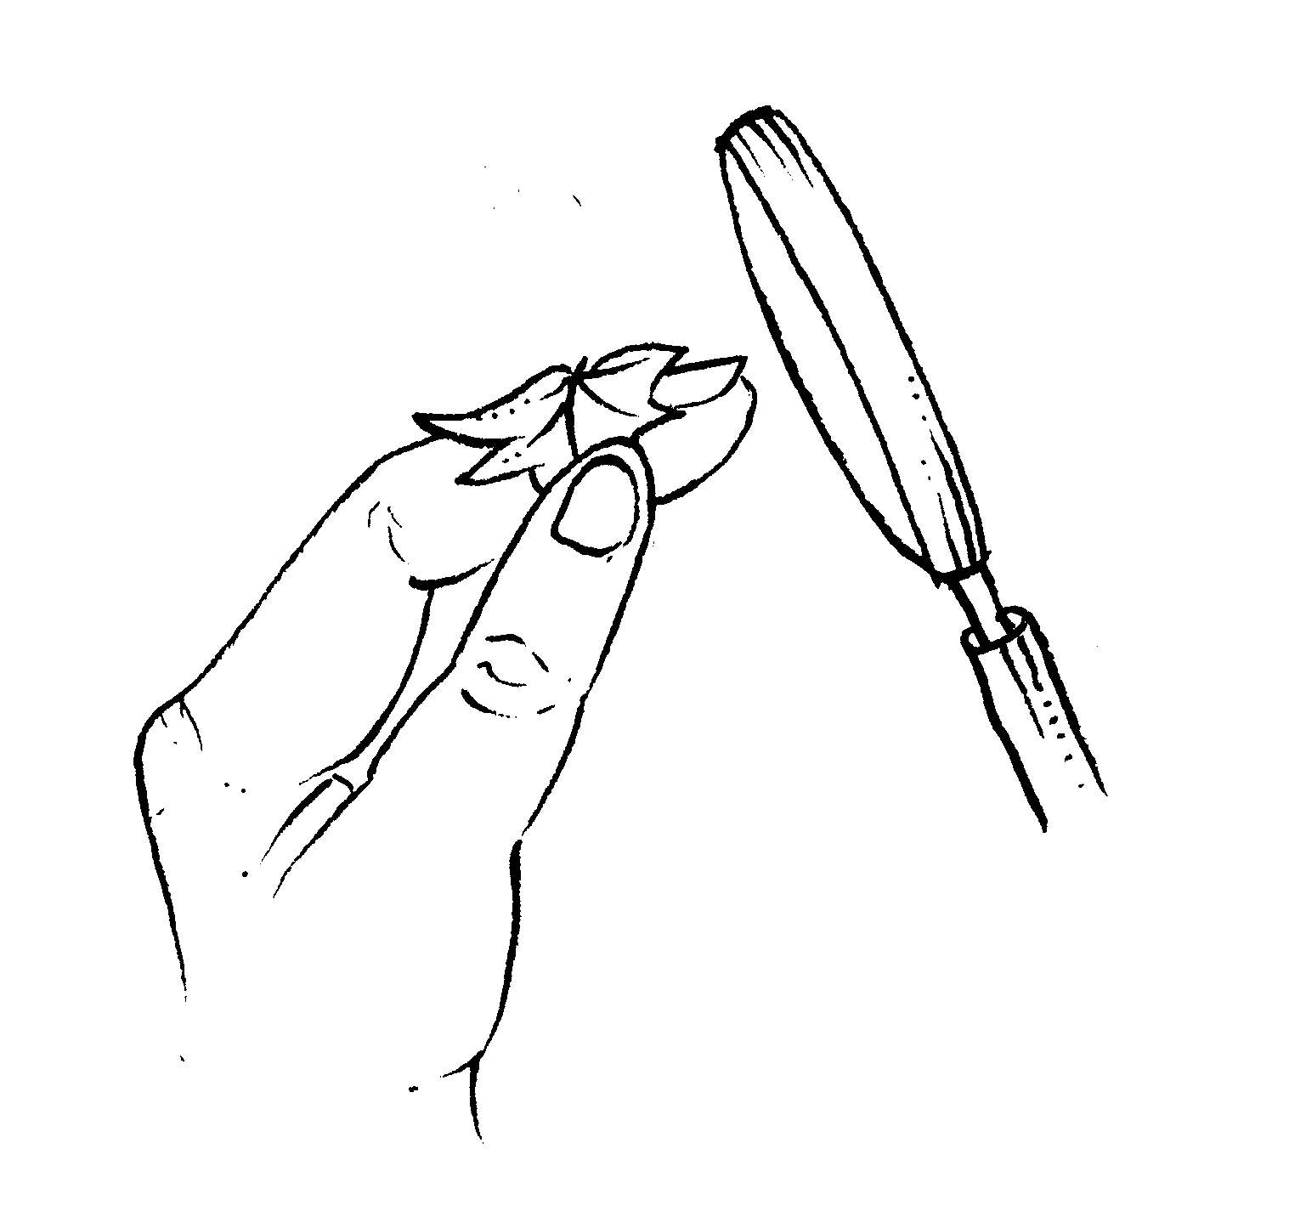
- Are the sepals turned back? .....................................................................................
wrap the leaf round your finger and use a magnifying glass to see the hairs

4. Are the leaves covered in tiny hairs? ................................

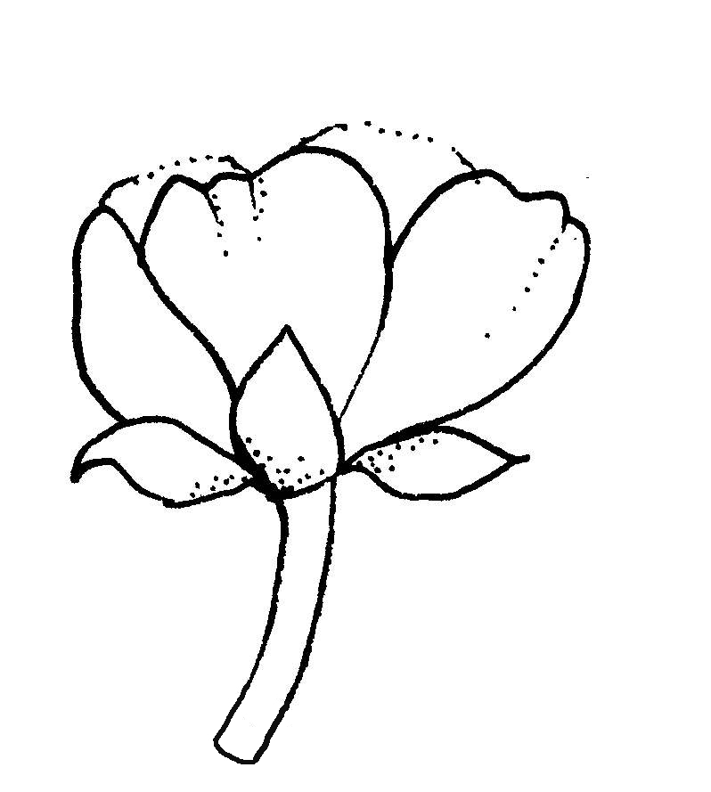
5. Do the flower stalks have clear grooves
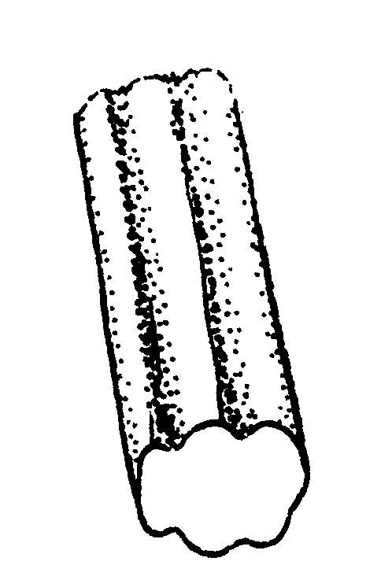
running along their length? ...........................................................

6. What sort of place was the plant growing in
(e.g. a grassy field, a woodland, the edge of a pond)?.............................................................................

7. Is there anything else interesting that you have noticed about your plant?
..................................................................................................................................................................................

.................................................................................................................................................................................



Now use the key to find out the name of your ‘buttercup’

