Forces and Magnets: Magnet Magic

Supports National Curriculum, Key Stages 1 and 2, Units 1E and 6E

Suitable for years 4,5 and 6.

The time for the session is about 1 hour (longer if items 12 and 15 are included). This can be varied by taking shorter paths through the material. Choices may depend on the apparatus available or the particular needs of the class.

Outline of content
Aims to
- establish what the children already know, using an intriguing demonstration
- use a class experiment to find which materials are magnetic
- investigate bar magnets through class experiments to show repulsion as well as attraction
- discuss action at a distance, if appropriate compare with the force of gravity
- demonstrate that one end of a magnet always points North when freely suspended and that a compass is a suspended magnet
- use games to reinforce ideas about magnetic and non magnetic materials
- use a game to learn about computer memory
- demonstrate other magnetic effects which link with electric currents
- demonstrate a very simple motor to explain that a magnetic field together with an electric current can cause movement
- discuss up-to-date applications of motors by linking the children’s knowledge with their experience.

Points to note:
Please read the notes about safety and agree the assessment with the teacher before the session!

Cross References
- The slides in the PowerPoint presentation are referenced in the table.
- As the presentation may be running throughout the session some simple slides provide a suitable background, alternatively switch to a black screen.
- Apparatus details are below the table and are linked to the relevant sections.
- Notes about safety are included at the end of the document

Vocabulary
The presentation uses expressions included in the KS 1&2 strategies http://www.standards.dfes.gov.uk/schemes2/science/?view=get

Misconceptions to be corrected
- All metals are magnetic materials
- Magnets only attract
- Magnets only attract (and repel) through air
- Gravitational forces and magnetic forces due to the Earth are confused
- The physics that they learn is not relevant to their everyday lives.

During the trial visits teachers commented that the children enjoyed the practical exercises the whole group took part enthusiastically.

Magnet Magic

Activity | Discussion | Aims/facts
Powerpoint Slide 1 should be showing as the class enters.  1. Demonstration - hovering butterfly  See Apparatus List  Start with the box facing away from the class. Once the class is settled, turn the box round holding the butterfly loosely. When released, the butterfly will hover.  See safety notes on neodymium magnets. | Ask what stops the butterfly falling down. Once they realise that there is a magnet on the top of the box, ask whether a real butterfly stay hovering in this way. Ask what is special about the butterfly in the demonstration. They will point out that the feelers are metal. (You might like to point out that there are very tiny magnets at the ends of the feelers making it look like a real butterfly.) They may notice that the butterfly is very light so that the force due to the magnet can hold the butterfly up.  The next activity will help to find out more about what the feelers are made of. | To catch the children’s attention and find out what they know.
- Class activity  Hand out a magnet and a selection of objects made of various materials to each group.  See Apparatus List  Ask the children, in groups of about four, to find out which objects are attracted by the magnets. They should also test other objects around them.  For older groups, it might be appropriate to give them sheets to complete. Alternatively their findings can be discussed and, if there is an interactive white board, the table in Show Powerpoint Slide 2 could be completed.  See Safety Notes: The objects that are handed round should be checked that they do not have sharp edges or places where the children can trap fingers | After the children have worked in groups for a few minutes, ask which objects are attracted by (or hang onto) the magnet.  Discuss whether it is the shape or the  material that determines whether the magnet attracts an object.  If they decide that magnets attract metals then help them to notice that the copper and brass objects are not attracted. Help them to conclude that only the iron and steel objects are attracted. (Only mention cobalt and nickel if this seems appropriate.)  Link back to the butterfly demonstration and point out the feelers are made of iron. | Iron and steel are the common magnetic materials.
3. Show Powerpoint Slide 3  Explain that the ends of bar magnets attract objects made from magnetic materials. These are called poles. | Ask which parts of the magnets attract the objects.  . | The ends of the bar magnets are called the poles of the magnet.
- Discussion about magnetic  forces Show Powerpoint Slide 4  Explain that the forces can be represented by arrows. Through discussion explain that an arrow shows direction and its length represents the size of the force. | Discuss what is happening as the magnets attract the objects. They may say that the magnet pulls the iron towards it. Encourage them to link magnets with forces. They should notice that the magnet can be turned round and both ends attract the iron and steel objects.  (Collect in the selection of objects.) | Magnets exert forces.  The forces can be represented by arrows.
- Class activity  Hand out a second magnet per group and ask them to place the magnets together in different ways. Show Powerpoint Slide Slide 5  See Apparatus List | They should find that in some positions the magnets repel each other.  Make sure they understand the word repel.  There must be 2 sorts of poles  (Collect in the magnets) | There are two sorts of magnetic poles.  Unlike poles attract  Like poles repel.
- Demonstration  Hang a magnet by a fine thread and allow it to settle. Disturb the magnet and it will settle to point in the same direction. Repeat.  See Apparatus List  Show Powerpoint Slide 6  Explain that the magnet is being attracted because the Earth is like a huge magnet.  The end of the magnet which points to the Earth’s North Pole is called the north seeking pole.  Show Powerpoint Slides 7, 8, 9 | Ask what they notice.  Ask them to think out possible reasons why the magnet always points in the same direction.  Ask them what people use to find their direction. Explain that a magnetic compass is a magnet that can swing round freely.  (Some children might know that magnetic and true North are different.)  A plotting compass is a tiny magnetic compass.  Note: homing pigeons can find their way using the Earth as a magnet. | The Earth is a huge magnet.  A magnetic compass uses a magnet that can swing freely.
- Demonstration  Place a strong bar magnet on an OHP. Sprinkle paperclips or dressmakers’ pins over it. They will cling to the poles.  Then scatter plotting compasses around the magnet. They should all be deflected.  See Apparatus List  See safety notes | Ask the children what causes the pins to jump to the ends of the magnet. They should say that the poles attract the pins strongly.  Ask what they notice when the compasses are placed near the magnets. Encourage discussions about the magnets not needing to touch the compasses to deflect them. | Magnets produce forces across empty space
- Discussion  The Earth’s force of gravity and the force due the Earth’s magnetism. | Ask for other examples of forces that act on things they do not touch. Get them to suggest gravity. Agree and ask in what way gravity is different. They should say that gravity only pulls but pulls everything while magnets pull and push but only on magnetic materials or other magnets. | Clear any confusion between the force of gravity and the force due to a magnet.
- Show Powerpoint Slides 11, 12, 13  Use these slides to reinforce the facts about magnets. |  | Magnets have a north and a south pole.  Unlike poles attract.  Like poles repel.
10. Game A  See Apparatus List  Show Powerpoint Slide 14  Each group should select one child who will act a seeker. This child should cover its eyes and the others should hide the magnet in a box or in the foil.  When ready the seeker should use the compass to find the magnet.  See Safety Notes: The boxes should be checked that they do not have sharp edges or places where the children can trap fingers. | Let them play the game and discuss this in their groups for a while. Then ask what is happening and ask groups to explain.  They should find that they can locate the magnets easily and find where the north and south ends are.  The cooking foil is important to reinforce that not all metals are magnetic.  NB The pointed ends of the compass needles are the north poles (when made but are sometimes reversed in use).  (Collect boxes) | Reinforce:  - that magnetic forces act at a distance.
- Game B  See Apparatus List  Repeat the game with all the boxes made of magnetic material. The seeker will be unable to find the magnet because the compass is attracted to all of the boxes.  See Safety Notes: The boxes should be checked that they do not have sharp edges or places where the children can trap fingers. | Ask why they cannot find the magnet.  Ask what is different.  Encourage the children to discuss what they have learned and ask questions. Use the discussion to revise and reinforce. | Reinforce that iron and steel are the common magnetic materials.
- Computer memory game.  Ask one child to arrange magnets in the slots in a box  See Apparatus List  Cover the row of magnets with black paper or a cloth so that they are hidden and ask a second child to use a plotting compass to ‘read off’ the code.  Show Powerpoint Slide 15  Take this opportunity to summarise what they have learned.  Show Powerpoint Slide 16 | Explain that computers use tiny magnets to store memory.  Discuss how a pattern can send a message.  Let them devise a way of doing this. Suggest that north is yes and south is no. So when the code is read the answers to questions are given.  Tell that soon there will be very new magnetic computer memory called MRAM. Computers with this will stay running even when you switch off – so time to start up will not be needed. | Magnets have lots of uses. Even in computers.
- Demonstration  Show Powerpoint Slide 17  See Apparatus List  Drop the block of metal down the copper pipe. Repeat and ask the class to say ‘now’ when they expect it to fall out of the bottom.  Repeat with the neodymium magnet ensuring that it falls on a soft pad. This will take much longer to fall.  See Safety Notes about neodymium magnets. | Explain that magnets cause lots of interesting effects.  There is no need to explain why the magnet drops so slowly (eddy currents) but point out that it is because the magnet is moving. (It is used as a magnetic brake.)  This links magnets and movement. | There is a lot more to learn about magnets than pushes and pulls. Magnets can be used in lots of ways.
- Demonstration – electromagnet  See Apparatus List  Place the nail and the wire on the OHP and place plotting compasses near to them to show that they are not magnetised.  Wrap the wire round the nail and place back on the OHP with plotting compasses around it. Complete the circuit and the compasses will swing round.  See Safety Notes. | Ask what is causing the plotting compasses to swing round.  Show the compasses are pointing to the ends of the nail.  Break the circuit and the compasses will swing back.  When they suggest that the nail is magnetised, ask how else this might be tested. Get them to think of objects being attracted. Discuss what the objects should be made of.  Then pile paperclips on the OHP and show that the nail will lift them.  Explain that when they learn more about science (physics) they will learn that electric currents and magnets are closely linked. | A magnet can be made when an electric current flows.
- Demonstration ‘kick’  (could be omitted)  See Apparatus List  When the hanging wire is connected in a circuit connected near a neodymium magnet it moves suddenly.  See Safety Notes about neodymium magnets- also wire may become hot | Connect the circuit then disconnect it.  Ask what they see.  Try it without the magnet so they understand that the wire only swings at the moment the circuit is connected when the magnet is close to the wire. It drops back when the circuit is disconnected.  (Magnets, electric currents and movement have now been linked. They may guess that electric currents are involved in activity 12.) | Magnets and electric currents can cause movement.
- Demonstration – Motor  See Apparatus List  Set up the apparatus as shown in the apparatus list in a position that can be seen by the whole class. Put the wire in place and it will begin to rotate. Show Powerpoint Slide 18  See Safety Notes about neodymium magnets- also wire may become hot. | This can be built up dramatically. When the wire spins the children are very impressed because they do not expect it to happen. | Motors use the fact that magnets and electric currents can cause movement.
- Discuss uses of motors.  After they have thought out some everyday things with motors in them.  Show Powerpoint Slide 19.  Lead into the idea that tinier and tinier motors are being developed  Show Powerpoint Slide 20. | Ask the children for examples of things that move when an electric current is switched on. Encourage them to think of examples of motorised toys, CD players etc. Discuss what the motor does in each case.  (They might suggest motor cars - explain that the engine in a car is different but that modern cars have electric motors that wind windows up and down etc.) | Physics is being used to develop better and better things used in our everyday lives.  There is lots and lots more to learn about science.
- Demonstration – robot  See Apparatus List  Show motorised toys or a robot toy which has several tiny motors in it.  See Safety Notes  Another example could be to switch on an electronic camera to show the lens move out. | Discuss and point out that developments are being made continuously.  Very tiny motors have been developed recently that are so small that they cannot be seen with our eyes!  Show Powerpoint Slide 21. | Scientists do amazing things!  Physics is in everything.

Apparatus for Magnet Magic

1. Demonstration

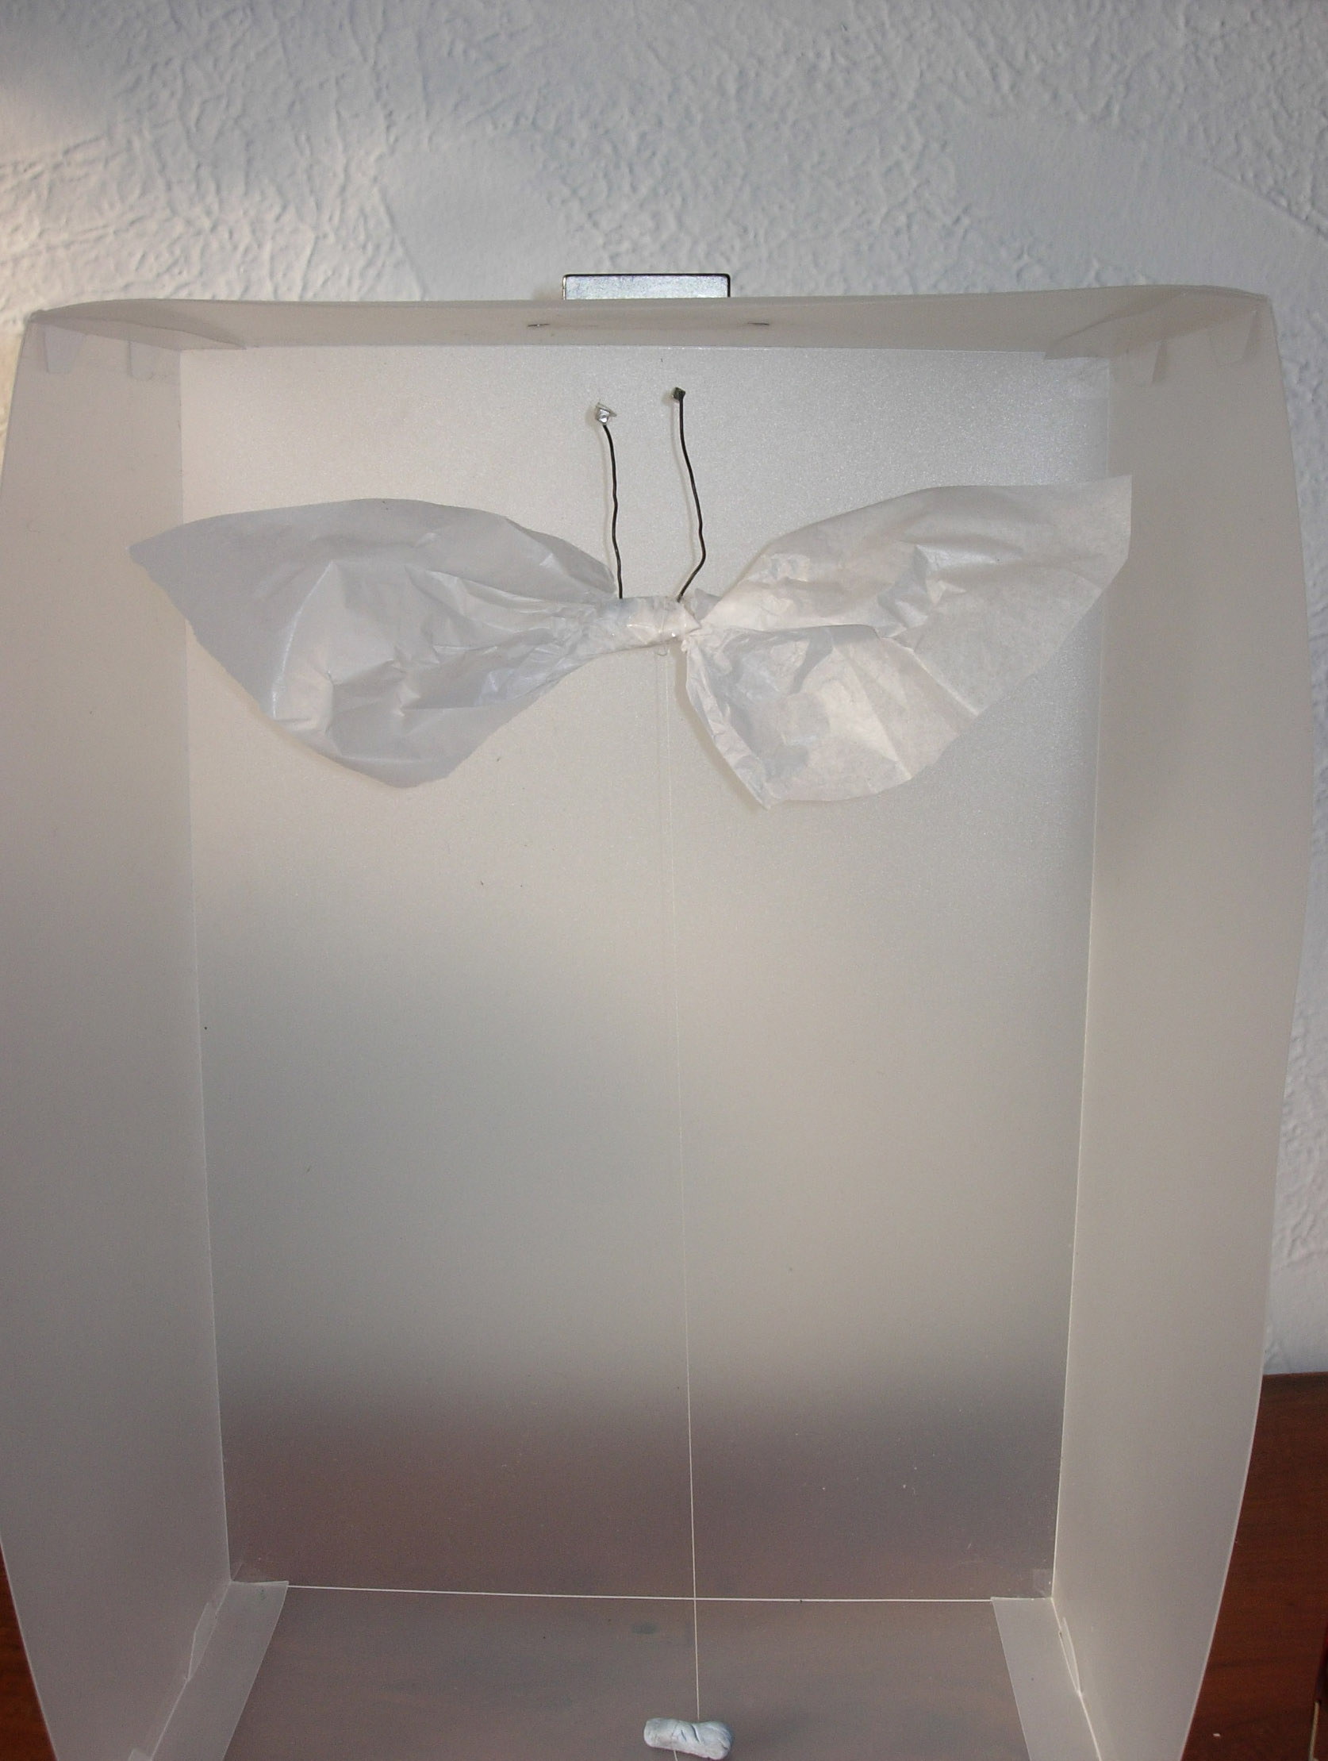
Neodymium magnet
Blu tack and fine thread
Tissue paper butterfly with tiny neodymium magnets on iron wire antennae

(See notes about safety for neodymium magnets.)
Neodymium magnets can be purchased online.
Eg http://www.powermagnetstore.co.uk/
Note: for iron wire use florists wire.

2. Class experiment
- 1 bar magnet per group
- a selection of objects made of different materials eg some bright plastic objects, wooden spoon, cheap steel spoon, enamel cup, plastic cup, copper ornament, cardboard, brass candlestick, wire coat hanger (end bent round so not sharp), a twist of florist’s wire (almost pure iron).
NB Modern 1p and 2p coins are made from copper-plated steel.
To aid the discussion, it is useful to have some examples of the same type of object made of different materials.

5. Class experiment
- a second bar magnet per group

6. Demonstration
- a bar magnet with a long fine thread (nylon fishing line or invisible thread) tied around it so that it will hand horizontally and swing freely. A paper sling could be used so that the magnet balances horizontally.
Note: if sewing thread is used then it is difficult to ensure that the twist has been removed so that the magnet does not rotate continuously.

7. Demonstration
- Overhead projector (OHP)
- Magnet
- Small paperclips or dressmakers’ pins
- Plotting compasses- – should be transparent – ie clear on both sides

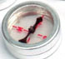

£3.50 for 10
http://www.schoolmarket.co.uk/pages-productinfo/product-8067/commotion-double-sided-compasses-pack-10.html catalogue code 50118

10. Game A
Per group:
- a plotting compass
- magnet
- wooden box
- cardboard box
- aluminium cooking foil
- plastic food container
- ( variations on this according to availability)

11. Game B
Per group:
- a plotting compass
- magnet
- three iron or steel ‘tins’ or boxes or baking ‘tins’
(Note: if there are too few of these for all the groups, then this could be done by one group who explain what happens to the remainder.)

12. Computer memory game – demonstration with pupil involvement
(could be omitted)
- Box with a row of 6 deep slots
  - could be slots in a block of polystyrene from packing.

- One magnet per slot
- Cloth or paper to cover magnets
- Plotting compass
- Card to display ‘code’

13. Demonstration
- length of copper piping about 1.5 metres long
- neodymium magnet (see notes about safety) which slides easily down the pipe
- block of metal about the same size and shape as the magnet
- soft pad for magnet to drop onto.

14. Demonstration – (electromagnet)
- overhead projector (OHP)
- length of insulated copper wire
- 1.5 V battery
- battery holder or magnetic connectors.
- wires and connections to complete the circuit
- long nail- (6 inch is best)
- plotting compasses
- paperclips
(Note: the nails should not be stored or carried near to the strong magnets as they will become slightly magnetised. If this happens the demonstration that the nails are not magnetised should be avoided.)

15. Demonstration – kick (could be omitted)
- Length of insulted wire (nonmagnetic eg copper)
- 2 stands
- Battery and connectors
- Switch or means of easily completing the circuit – eg crocodile clip
- Neodymium magnet
clamp
clamp
neodymium magnet
This needs to be arranged in a position so that the lowest point of the loosely hanging loop of wire can be seen by the whole group.
When the switch is connected the wire is ‘kicked’ sideways.
When the circuit is broken it falls back.

16. Demonstration - motor
This demo is quite small so find a good place to put this so that the whole class can see without moving closer.
- 1.5 V AA battery
- Neodymium magnet ( this is orientated so that the magnetic field is vertical
- ie one pole is at the top and the other at the bottom. ) - could be a button shaped magnet
- Small iron or steel spacer ( not insulated)
- Stiff copper (non-magnetic) wire bent to the shape shown in the picture. The wire must make electrical contact with the spacer. If lacquered wire is used, the lacquer along the middle of the length of the wire must be removed.

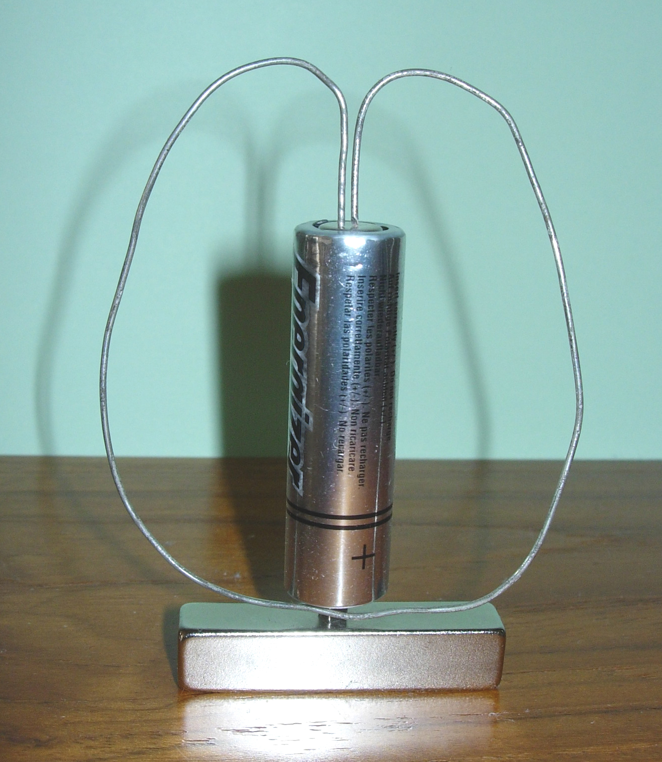
Bare non-magnetic wire.
Copper works well but should not be lacquered.
Current

Magnetic field
The force on each part of wire causes a horizontal couple perpendicular to the currents so the wire rotates.

(Note: the magnetic field is vertical, currents are flowing horizontally through the wire at its lowest point, therefore there are horizontal forces perpendicular to both the currents and the field causing the wire to rotate. This explanation is not needed for the children.)

18. Demonstration of robot, motorised toys and small devices with motors
Examples Robot - Climbatron- walks up windows etc £4.99
travel fan
camera with a lens that moves out when switched on.

Any devices demonstrated should be checked to ensure they have no sharp edges and do not become hot when working. Only examples using low voltage batteries should be used.

Note: Most primary schools have a good number of magnets. However, if conventional bar magnets are not available the ‘sticks’ from a ‘sticks and balls kit’ can be used. They are made with magnets set at each end of plastic ‘sticks.

Important notes about safety

Avoid using small magnets with young children. The children should not drop the bar magnets because the magnets will lose their magnetisation.

Neodymium Magnets (Activities 1, 13, 15, and 16)
- Neodymium Magnets are dangerous because of their strength and the fact that they easily shatter and produce sharp fragments.
- They should all at times be treated with respect and not left with children unsupervised. Nor should primary-age children be allowed to handle them.
- There is a danger of nipped flesh if they are allowed to snap together.
- They should be kept away from electronic apparatus and credit cards, digital cameras, watches, mobile phones, pacemakers etc.
- When the neodymium magnet is dropped down the copper pipe it should land on a soft pad.
- Care should be taken to ensure the magnets do not jump and become attached to a steel shelf bracket or furniture frame and so be lost.

(Activities 2, 10 and 11) The objects and boxes that are handed round should be checked that they do not have sharp edges or places where the children can trap fingers.

(Activity 7) Avoid using iron filings to demonstrate magnetic poles. They stick on magnets and may irritate the skin of younger children. If dressmaking pins are used, take care to collect all of them and not let any fall on the floor. To avoid losing any, they can be placed in a sealed transparent plastic bag which is placed over the magnet on the OHP. Do not allow the children to handle the pins.

(Activity 15 ) In the wire ‘kick’ demonstration, connect the circuit and then disconnect it after a few seconds to avoid the wire becoming hot. Do not allow the children to help with this experiment.

(Activity 14) The wire and battery in the demonstration electromagnet may become hot due to the large currents flowing. Complete the circuit for only short periods of time. Children like to do this as a class exercise but it is difficult to ensure that some do not leave the circuit connected long enough for it to become hot.

(Activity 16 ) If the wire in the demonstration motor spins well it will become hot. Demonstrate this where the children will not pick up the wire.

(Activity 18) Any motorised toys demonstrated should be checked to show they are in good condition. Examples of motors that work from the mains should not be used because they would need to have a portable appliance (PAT) test before use.

