Heathland Plants: Web Challenge

TASK:
Lowland heathlands have a very distinctive plant community. In this activity you will be using the internet to find out about the types of plants that grow in heathlands and how they are different to plants in other habitats.
Question 1: | 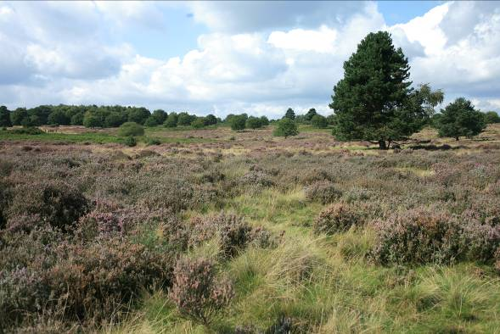  Look at the photograph below of a typical heathland plant community :
a. | How would you describe this habitat?
b. | What can you say about the relative cover of trees, shrubs and grasses?
Question 2: | Name three shrubs that characterise lowland heathland.
Question 3: | What characteristics of heathlands and features of heathland soils make habitats particularly challenging environments for plant species to survive in?
Question 4: | Because of the unique abiotic conditions found on heathlands, the plants that grow there have to be highly specialised to survive. Use the internet to research the following three plants. What adaptations do they have to the heathland environment?  The plants you need to research are: common heather (Calluna vulgaris), dwarf gorse (Ulex minor) and sundew (Drosera rotundifolia). Tip: Try to find out how they increase their nutrient uptake and how they may reduce water loss.
Question 5: | Mosses and lichens are commonly found in heathland habitats.
a. | How are mosses and lichens different to vascular plants?
b. | Find the name of one moss and two lichen species that may be found on heathlands.
Question 6: | Bracken can become a dominant plant in heathland communities, out-competing other heathland plant species and reducing plant diversity. Whilst some bracken is important in heathland habitats, too much can reduce the biodiversity and quality of the heathland.  Find out two reasons why bracken is so effective at out-competing other plant species.
Question 7: | Heathlands can typically be either dry heaths or wet heaths and mire.
a. | List some plants that are associated with each of these different heathland habitats.
b. | Which of these types of heathland typically has a greater plant species richness?
Question 8: | Most heathlands have been created by humans and all heathlands have a rich cultural history. Find out some ways that humans used to use the heather plants that they harvested from heathlands.

