Heathland Field Study Workbook: How Polluted?!

You will be spending today acting as an environmental scientist. You’ll get a chance to have a go at measuring pollution levels using some different techniques, and then find out how pollution might be affecting the ecology of this habitat. We’ll be monitoring a very special habitat – lowland heathland; a habitat that’s rarer than rainforest and supports a large number of different species, some of which are threatened or endangered. Keep your eyes peeled and be careful where you stand!
After today you could be great at:
- Explaining what nitrogen pollution is, where it comes from
and why it’s a problem;
- Using bioindicators to assess environmental conditions;
- Using a quadrat to sample vegetation;
- Identifying common plant species that occur in heathlands;
- Measuring different parts of the physical environment (abiotic factors!);
- Understanding how the physical environment can affect the organisms that live there.
Workbook Contents

Pages 2 - 3 | Activity A: Measuring nitrogen pollution in the soil using soil chemistry tests
Pages 4 - 5 | Activity B: Measuring nitrogen pollution in the air using lichens as bioindicators
Pages 6 – 10 | Activity C: Investigating the heathland vegetation
Page 11 | Summary and evaluation

Activity A: Soil Chemistry Tests
Testing for pH
- Carefully open the green capsule and empty the powder into a test tube.
- Use a trowel to dig a small hole about 10cm deep. Carefully take a sample of soil from the bottom of the hole - try not to collect any stones or plant roots.
- Fill the test tube to the first line with the soil you have collected.
- Open the bottle of water and fill the test tube with water up to the fourth line.

- Put a lid on the top of the test tube and shake it thoroughly.

- Find somewhere safe to place the test tube very carefully in an upright position where it will not be kicked, knocked or lost! Leave the contents of the tube to settle for at least 5 minutes. While it is settling prepare the nitrogen analysis (see below).

Testing for nitrogen (N)
- Take a sample of soil from about 10 cm below the surface.
- Empty about one sixth of the water out of the bottle. Put about half a trowel-full of soil into the bottle – try not to put any stones or plant roots into the bottle. Put the lid on the bottle and shake thoroughly for about 1 minute (or until the soil and water are well mixed).
- Put the bottle in a safe place to allow the contents to settle without being disturbed. Note the time here ___________________. The mixture in the bottle needs to settle for at least 20 minutes.
- After 20mins check that the mixture has settled (there should be mud at the bottom of the bottle and clearer liquid at the top).
- Very carefully fill a test tube up to the fourth line with the liquid from the bottle. Do not get too much soil sediment into the test tube.
- Carefully open the purple capsule and empty the contents of the capsule into the test tube.
- Put a lid on the test tube and shake it thoroughly. Note the time here _______________.
- Leave the test tube somewhere safe for at least 10 mins to allow the colour to develop.
- Compare the colour of the liquid in the pH and nitrogen tubes against the chart on the front of the ‘mini soil test kit’ packet.
Complete the table below:
Test | Colour | pH/nitrogen value
pH
Nitrogen (N)

Questions
1.Soil from healthy (ie. unpolluted) heathlands should be acidic, ideally with a pH of 3-5.
Use the results of your pH test to explain whether or not you think the soil at your heathland is healthy.
_______________________________________________________________________

2. Healthy heathland soils should be deficient in nitrogen. What does your soil chemistry analysis suggest about the levels of nitrogen pollution in the soil in your area? Explain you answer.
_______________________________________________________________________
________________________________________________________________________________
3. The pH and level of nitrogen are two examples of physical or abiotic characteristics. Write a list of other abiotic factors that you could measure.
_________________________________________________________________________________
_________________________________________________________________________________
Activity B: Measuring Nitrogen Pollution in the Air using Lichens
Lichens are made up of two organisms living together; a fungus and an alga. Lichens are sensitive to the amount of nitrogen-containing pollutants in the air. Some species of lichen are tolerant of nitrogen pollution, whereas others need very clean air to survive. This means lichens can be used as bio-indicators (living indicators) of pollution levels. By looking at which species of lichen are growing in the area, and how abundant they are, we can work out how polluted the air around the heathland is. In this activity we will be searching for lichens on the trees surrounding the heathland.
Step 1: Select three trees. Try to select deciduous trees such as oak, ash or sycamore.
Step 2: On each tree choose the side of the trunk with the most lichens. There may be many different species of lichen growing on the trunk, but we are only interested in the nine indicator species shown on your lichen ID guide.
Step 3: Record the total amount of each indicator lichen you see on the trunk as follows:
Record | 0: | If there is none of the indicator species on the trunk.
 | 1: | If there is a small amount of the species (covering an area of less than ¼ of a sheet of A4 paper in total)
 | 2: | If there is a medium amount of the species (covering an areas of between ¼ and 1 sheet of A4 paper in total)
 | 3: | If there is a large amount of the species (covering more than 1 A4 sheet in total)
Record your results in the table on the following page……

 | Amount of indicator lichen on the trunk of each tree (0, 1, 2, or 3)
 | Example | Tree 1 | Tree 2 | Tree 3
Species of tree | Ash
Girth of tree (cm) | 65
Nitrogen-sensitive
Usnea | 0
Evernia | 0
Hypogymnia | 1
Intermediate
Melanelixia | 1
Flavoparmelia | 2
Parmelia | 1
Nitrogen-loving
Leafy Xanthoria | 2
Cushion Xanthoria | 1
Physcia | 3

What do your lichen observations suggest about the levels of nitrogen pollution in the area?
_______________________________________________________________________

Plants can be sensitive to the amount of nitrogen contained in the soil – some may thrive in nitrogen-rich soils, whereas others may struggle. Looking at which plants species are most common in the heathland can help you work out if the habitat is suffering from excess nitrogen being deposited in the soil where it can be taken up by plants (nitrogen deposition).
Activity C: Investigating the Effect of Nitrogen Pollution on the Heathland Vegetation
Nitrogen pollution is a problem for heathlands because nitrates in the soil encourage fast growing plants (like grass and bracken) to grow. These faster-growing species can out-compete slower growing plants (like heather). Eventually the heather will disappear and the heathland will change to a different habitat. This is predicted to occur when nitrogen deposition is greater than about 17 kg N ha⁻¹ year ⁻¹.

Using the information given above, the maps shown at the bottom of this page, and the results of your soil and lichen analyses, what is your prediction for the outcome of the vegetation sampling in the heathland? Do you think you will find that heather, or grasses and bracken are more dominant?
I think that.. __________________________________________________________
Because… _____________________________________________________________
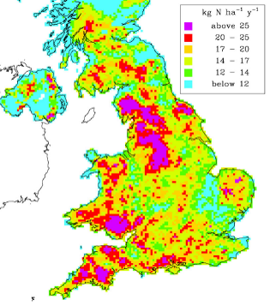
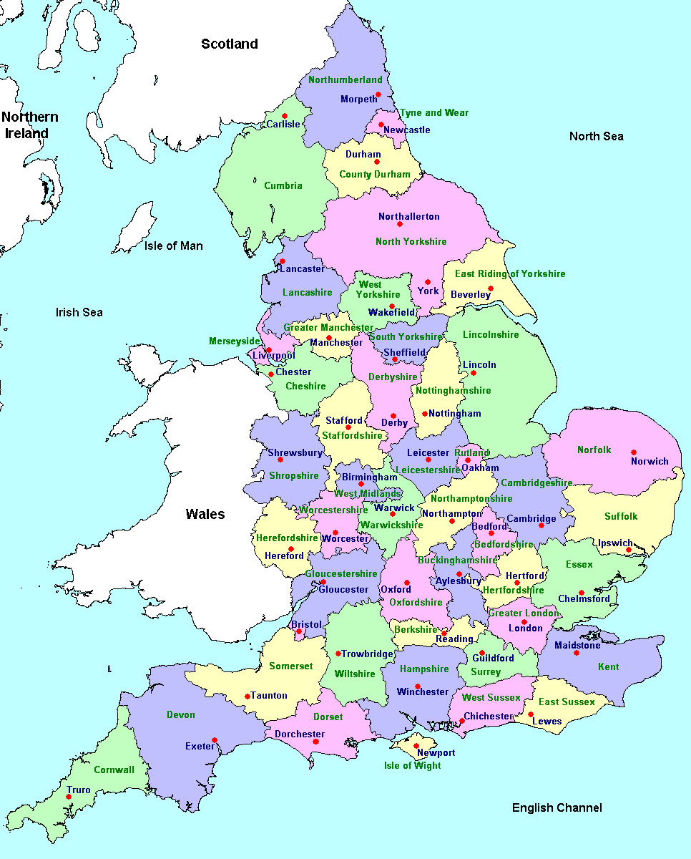
Nottinghamshire
Nitrogen deposition in 1997
Map of English counties

Nitrogen deposition 1997

In this activity you will be using quadrats to sample the heathland vegetation. You will record which plant species are present in each quadrat, and estimate how much of the ground surface each species covers (i.e., their percentage cover). This will help you to determine whether or not this area of heathland is suffering from the effects of nitrogen pollution.
Generating random quadrats
When collecting your vegetation data you should have no control over which patch of vegetation you sample with your quadrat, i.e., the vegetation should be randomly sampled. Lay out two long tape measures (ideally 50m) at right angles to one another on the ground, making sure that both tape measures meet at ‘0m’. Use your calculator to generate pairs of random numbers – write them in the table below. Use these pairs of numbers as the X,Y co-ordinates by plotting them against the tape measures. Place your quadrat so that the bottom-left hand corner of the quadrat is located at X,Y and so that your quadrat is aligned with its sides parallel to the tapes.
 | X | Y |  | X | Y
Quadrat 1 |  |  | Quadrat 6
Quadrat 2 |  |  | Quadrat 7
Quadrat 3 |  |  | Quadrat 8
Quadrat 4 |  |  | Quadrat 9
Quadrat 5 |  |  | Quadrat 10


Estimating percentage cover using a quadrat
Look down on the quadrat from above and identify all the plant species that can be found in it. For each species, estimate the percentage of the quadrat that it takes up. For example, in the image on the right you might estimate that species A covers 25% of the quadrat. Species often overlap (as shown in the image on the right) and there may be several different vertical layers of plants. Percentage cover may therefore add up to well over 100% for an individual quadrat.

Use your heathland plant ID guide to help you identify the species in your quadrats. For each quadrat record the percentage cover of each plant species in the table on the following page. Try to complete 10 quadrats!

Species indicating nitrogen pollution

Species indicating a lack of nitrogen pollution
Fill in this table to show the % cover of each plant type in each of your randomly selected quadrats. At the bottom of the table you can work out an average cover of each plant type (by adding up the numbers in each column and dividing them by the number of quadrats you completed).
 | Heather | Gorse | Heath bedstraw | Moss and lichens | Grass | Bramble | Bracken | Use these columns to record other plant species you find
Quadrat 1
Quadrat 2
Quadrat 3
Quadrat 4
Quadrat 5
Quadrat 6
Quadrat 7
Quadrat 8
Quadrat 9
Quadrat 10
Average

Summary and Evaluation: How Healthy is the Heath?
- Suggest two ways you could have made the data you collected in Activity A more accurate.
_________________________________________________________________________________
- Give a source of error that could have affected the reliability of your results in Activity B.
________________________________________________________________________________
- A good quality heathland will have at least 25% cover of heather and less than 50% cover of grass. Using the results you collected in Activity C, explain whether or not you think this is a good quality heathland.
_________________________________________________________________________________
_________________________________________________________________________________
- Why did you have to do at least 10 quadrats in Activity C?
_________________________________________________________________________________
- Do you think nitrogen pollution is a problem in this heathland. Use your results from Activities A – C to help explain your answer.
_________________________________________________________________________________
_________________________________________________________________________________
_________________________________________________________________________________

