
Are you a Hare or a Tortoise?

Would you be described as active, lively and energetic, or would lethargic, languid and sluggish be a better description?
Starter Activity:
Look at the following data from over 6000 children, given during Phase 3, and answer the following questions:

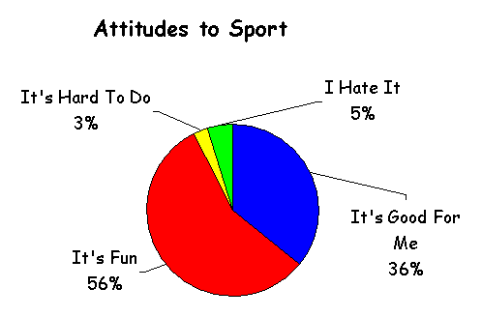

- Approximately what percentage of children regularly swim?
- Do all children watch TV?
- Which is the modal activity?
- If your class was asked about which activities they regularly took part in, would the results be similar to the ones shown above?
- Do active people also read and watch TV?
- What is your class’s attitude to sport?
Main Activity:

Below is a table showing the total average calories needed each day.

 | Age | Weight kg | Calories
Boys | 9-12 | 27-40 | 2300-2500
Boys | 12-15 | 41-50 | 2600-2800
Boys | 15-18 | 51-70 | 2900-3200
Girls | 9-12 | 28-37 | 2250-2300
Girls | 12-15 | 38-49 | 2400-2550
Girls | 15-18 | 50-57 | 2200-2300

Remember, the more active you are the more calories you use.
This resource is from the CensusAtSchool project at www.censusatschool.org.uk

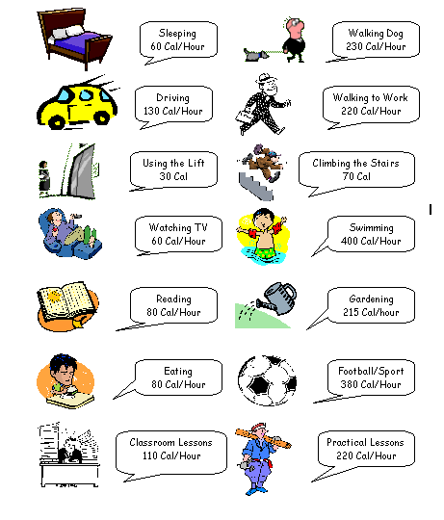

We have designed a calorie diary below for a day in the life of Fred!
Using the information to the left fill in the calories he is using up.

Can you spot what usual activities have been left out of this diary?

A day in the life of Fred!

Now design your own calorie diary for a typical day. You can choose either a school day or a Saturday – state which.

Plenary Activity:
Can you see areas in your life where you could be more active? For example do you take the lift when you could use the stairs?

This resource is from the CensusAtSchool project at www.censusatschool.org..uk

