
activity sheet 1/5

theme: leisure & lifestyle

job: Nick Dawes,
First Team Physiotherapist,
Bristol City Football Club

Football players need to be really fit. But sometimes they injure
themselves. The job of the physiotherapist is to get them back to
peak fitness as soon as possible. You will investigate two ways
that physiotherapists assess fitness.

Procedure: Sit and reach test
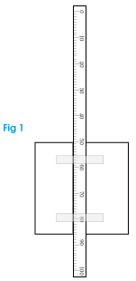

This test measures the flexibility and strength of muscles in the back of your thighs (hamstring muscles) and lower back. It’s important in most sports and can be improved by stretching exercises.

Before you start, do some gentle warm-up activity for five minutes.

Warning: The test is not competitive. Do not try to stretch further than is comfortable.

- You need a box 30-40 cm high. Tape a metre rule across the top, with the 50 cm mark level with the front.

- Sit on the floor, or a sports mat, with:
- legs straight out – knees not bent
- feet shoulder-width apart, flat against the box.

- Reach out with your hands on top of each other and middle fingers lined up together on the metre rule.

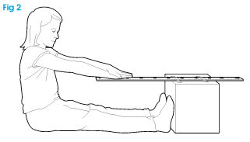
Continued>


activity sheet 2/5
theme: leisure & lifestyle

- Gently lean forwards, sliding your fingers along the rule, as far as you can comfortably reach. Do not jerk forwards. If it hurts, stop.

- Hold your position for two seconds, while your partner records the position of your finger tips.

- Relax for a minute while you calculate your reach:

Reach = finger tip position – 50.

(If you didn’t reach your toes, reach will be negative.
For example, 48 – 50 = –2)

- Repeat the test three more times. Calculate your mean (average) reach.

Name |  |  |  |  |  | Partner’s name
Reach (cm) | 1 | 2 | 3 | 4 |  | Reach (cm) | 1 | 2 | 3 | 4
Mean reach cm |  |  |  |  |  | Mean reach cm

- Swap with your partner to measure their reach. Compare your results with your partner’s.

- Look at the class results.

- Is there a difference between those who play a lot of sport and those who don’t?

- Decide whether the reach test indicates how fit people are.

activity sheet 3/5
theme: leisure & lifestyle

Procedure: Assessing cardiovascular fitness

Cardiovascular fitness means how well your heart and blood vessels carry oxygen around the body – in particular to your muscles. You will measure your partner’s pulse rate and blood pressure.

Before you start, do some gentle warm-up activity for five minutes.
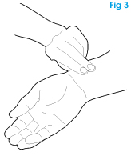

- Make sure that you know how to take the two measurements.

- If using an instrument, follow instructions carefully.

- To measure pulse rate by hand, find a pulse in the wrist (Fig 3) or temple (just in front of the top of the ear). Count for 15 seconds. Multiply the count by four to get the pulse rate per minute.

- Your partner must sit quietly for five minutes – for example, listening to your teacher introducing this investigation.

- Measure your partner’s resting pulse rate and blood pressure. Record them in the table below.

- Your partner must now exercise hard for three minutes – running on the spot, step-ups, press-ups, or similar.

- Immediately measure and record your partner’s pulse rate and blood pressure again.

- Measure pulse rate again every minute until it returns to the resting rate. Record the time taken to return.

- Measure blood pressure again after three minutes, and when the pulse rate has returned to normal.

Note: If pulse rate doesn’t return to normal within 10 mins, stop and
record >10 min
Continued>
activity sheet 4/5
theme: leisure & lifestyle

Name |  |  |  | Partner’s name
Time (min) | Pulse rate  (beats per min) | Blood pressure  (mm Hg) |  | Time (min) | Pulse rate (beats per min) | Blood pressure (mm Hg)
Rest |  | / |  | Rest |  | /
0 |  | / |  | 0 |  | /
1 |  |  |  | 1
2 |  |  |  | 2
3 |  | / |  | 3 |  | /
4 |  |  |  | 4
5 |  |  |  | 5
6 |  |  |  | 6
7 |  |  |  | 7
8 |  |  |  | 8
9 |  |  |  | 9
10 |  |  |  | 10
Time for pulse rate to return to resting rate min |  |  |  | Time for pulse rate to return to resting rate min
Blood pressure at this time /  mm Hg |  |  |  | Blood pressure at this time /  mm Hg

activity sheet 5/5
theme: leisure & lifestyle

- Swap jobs: your partner takes measurements and you do the exercise. Record these results in the second table. Compare your results with your partner’s.

- Look at the class results.

- Are there differences in lifestyle and sports activity between pupils whose pulse rate returns to normal quickly, and those that take longer?

- Decide how pulse rate and/or blood pressure can be used to indicate fitness levels.



Studying science and maths can transform your career options. Future Morph: become someone.

