These notes explain how to run the ‘Climbing the Tree of Life’ activity in class. They talk you through using the interactive Tree of Life, provide answers to the student questions and illustrate curriculum links. NB: You will need to have Flash 10 installed on your computer to perform these tasks.

Aims of activity:
To encourage students to make use of the Tree of Life video and comic to stimulate thinking and discussion surrounding the relationships between animals on Earth.

Learning objectives:
- To appreciate that the animals alive today (along with all other living things) can trace their ancestry to earlier forms of life.
- To be aware of the nature of the links between certain groups of animal.
- To understand that the environment and conditions at various times in Earth’s history have favoured the evolution of living things that has taken place.
- To be able to identify the classes of arthropods and vertebrates.

Guidance:
The Tree of Life activity should provide students with insight into the relationships between species of life on Earth, both today and the past. The activity provides a structure and an incentive for students to explore the Tree of Life interactive video, which can be streamed and downloaded from www.wellcometreeoflife.org. You can watch the video by clicking on the ‘video’ link and explore the interactive via the ‘interactive’ link.
You can find a quick guide to using the interactive Tree of Life by clicking on the question mark icon in the interactive. This will show you how to get images, information and web links about the living things featured, as well as how to find common ancestors of any two living things you select. It explains how to change views of the interactive so you can see branches in proportion to length of time, relationships between branches, and links between different living things.
You can also switch back and forth between the interactive and the video.

It is suggested that teachers use the activity to discuss the mechanism of evolution with their students.

Materials: Interactive whiteboard or similar; computers with fast access to the internet; student worksheet (one per student).

Time: 100 minutes
- Discuss the variety of living things – focus on animals, citing some unusual examples (sponges, jellyfish...) so that students are encouraged to think about how diverse the kingdom is, and what are characteristics that determine what an animal is.
- Use the Tree of Life interactive to explain how Darwin suggested that all living things can trace their ancestry back to very few earlier forms. Talk about the gross structure of the tree while navigating around it on an interactive whiteboard (earlier evolving forms tend to be located on the left, with vertebrates on the right – mammals on the extreme right). Refer to the guidance on navigating the Tree of Life interactive.

- Hand out the question sheets, explaining that the information needed to complete them is partially found in the video. The rest of the questions may involve some discussion and research.
- Show the Tree of Life video.
- You may wish to pick out some moments from the Tree of Life video and indicate where the events took place on the Tree of Life interactive. Encourage students to see how the different configurations of the interactive can be used to help them work out what is happening at different junctures. Select one or two living things and click on the text, images, rotating video and web links.

TIME | EVENT
0:47 | cells formed
1:17 | internal cavity
1:54 | development of sense organs
2:10 | hard protective skin
2:24 | some armoured invertebrates venture onto land
2:49 | wings appear – insects arrive and life moves into the air for the first time
3:10 | development of a backbone, skull and hinged jaw for some animals in the sea
3:40 | backboned living things on the land
4:05 | first truly terrestrial animals – with dry skin and egg with watertight shell
4:28 | destruction of much of life on Earth, especially the dinosaurs
4:53 | arrival of the mammals

Key concepts:
- The reason why we classify animals in a branching structure is because, according to Charles Darwin, all life shares common ancestry.
- There are five kingdoms of living things.
- The main division we tend to use in categorising animals is whether or not they have a backbone.
- The environment plays a major role in natural selection.
- At times whole populations or species have died out.

 | Questions | Answers
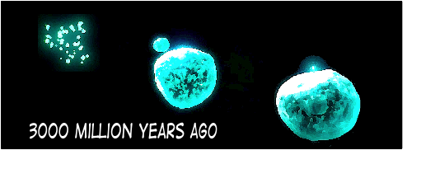 | What event took place that led to the development of the earliest living cells around 3000 million years ago? | Formation of cells from microscopic particles
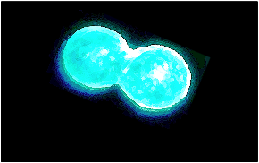 | How did the earliest cells reproduce?  Do any living things still reproduce in a similar way today? | By division – one cell  becomes two  Bacteria and yeast (and members of the kingdom Protoctista)
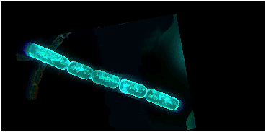 | How did algae come to be formed from cells? | Individual cells did not fully separate when dividing
 | Why is it helpful for this animal that lived on the sea floor to have sense organs at the front of its body?  How did the little projections from each segment of its body help this animal survive? | It was able to sense in the direction it was moving  Prior to this development, movement was brought about by the beating of microscopic cilia around the cells of animals. Segmented bodies meant that the claw-like projections could be coordinated and movement was faster and the animal could change direction more easily
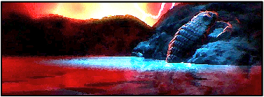 | When did animals with hard protective skins first climb out of the sea and walk on land? | 450 million years ago
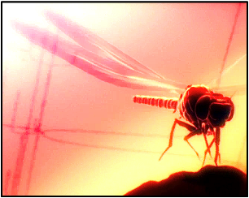 | This insect had a wingspan of nearly 1 metre. To grow that large and be able to fly, it must have been able to find a lot of food and not had many predators. Think about what may have happened to cause it to die out. Explain your ideas. | - As competition increased, available food supply decreased so it could not get enough food to provide its large energy requirements  - Possibility that atmospheric oxygen diminished so that it was unable to extract as much energy per unit volume of food
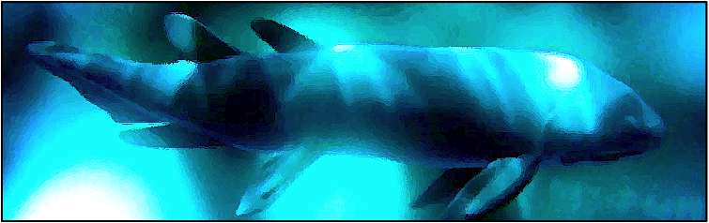 | Meanwhile, as insects were ruling the land the early fish were developing. What happened to their body structure that made them into the rulers of the seas?  (3 things) | Backbone developed  Skull  Hinged jaw making catching food more efficient
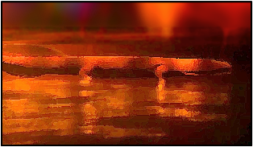 | One group moved from the sea to the land. Do you think this simply occurred one day or were they developing over time?  Why were these animals not truly land-living? | The conditions in the sea and on land are very different – especially in relation to getting oxygen. Probably long period of time  They had to keep their skins moist and return to the sea to lay eggs
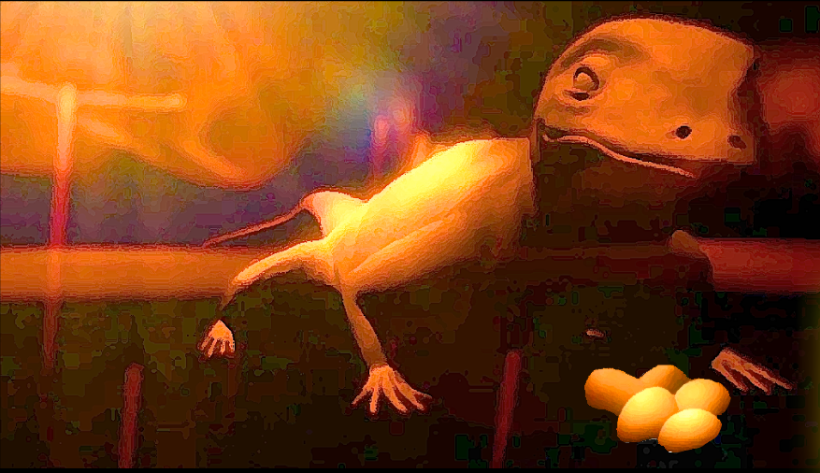 | These animals were the first terrestrial vertebrates (vertebrates are animals with a backbone). There are five groups of vertebrate – fish is one group. What are the other four groups? Give one example of an animal alive today from each group. | Fish  Amphibians  Reptiles  Birds  Mammals
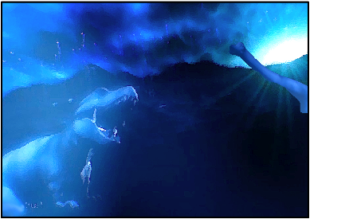 | The dinosaurs dominated the Earth for many years. Which group of vertebrates did they belong to? | Reptiles
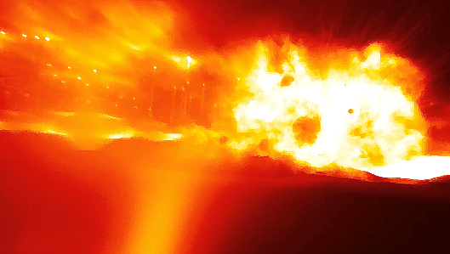 | What great disaster is thought to have happened about 65 million years ago that caused the dinosaurs to die out? Use the internet or a library to discover how this event could lead to the death of the largest animals that have ever walked the Earth | Possibly a large meteor colliding with the Earth, causing so much dust to enter the atmosphere that no sunlight was able to penetrate
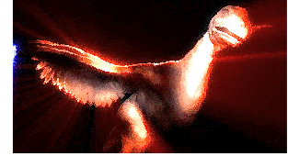 | The animal shown here is called Archaeopteryx. It died out a long time ago but a number of fossils have been found showing that it had sharp teeth, claws and feathers. What is special about this animal? | Could be the link between reptiles (dinosaurs) and birds, since it shares features of both – including claws, teeth, feathers
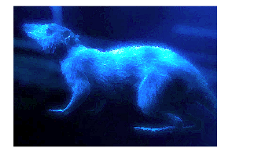 | Animals like this one existed at the time of the destruction of the dinosaurs, when they increased in number. They were the first mammals. What are the features that all mammals share? | Fur, warm blood and parental care. Mammals produce milk for their young from mammary glands – that’s how they get their name.
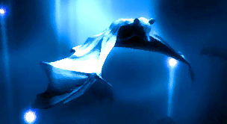 | Some mammals took to the air in a similar way to insects and birds. Is a bat more closely related to a bird or to a dolphin? Explain your answer. | A dolphin. The bat has fur and produces milk. Birds have feathers and cannot produce milk. The principle here is that classification is made on the appearance of the animal (its physical characteristics), not on its mode of feeding or where it lives.
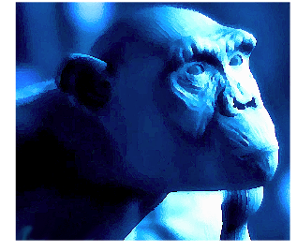 | Chimpanzees are mammals, and are our closest living relative. Would you expect the Tree of Life branches between chimpanzees and humans to have spread out very early on or more recently? Explain your answer. | More recently – actually very recently. The closer two species are, the more recent the branches of the tree of life diverged.

Further questions

Working in small groups of 2–4, carry out some research into some other forms of life on Earth.

- There are five kingdoms of living things. For each of the five kingdoms – prokaryotes, protoctists, fungi, animals and plants – use the internet or a reference library to find out the following:

    - a. Why are the living things in that kingdom grouped together?
    - b. What features do members of each kingdom share in common?
    - c. Examples of living things in the groups.

- Present your work as a panel in a museum, titled ‘Five Kingdoms of Life’. Panels are used to explain ideas to visitors who are passing through an exhibition. To be effective, they should be clearly written with not too much detail. They should also be attractively designed.

- Curriculum links:

ENGLAND
Attainment target 2:
Organisms, their behaviour and the environment

Level 4
Pupils describe some processes and phenomena related to organisms, their behaviour and the environment, drawing on scientific knowledge and understanding and using appropriate terminology, for example using food chains to describe feeding relationships between plants and animals in a habitat. They recognise that evidence can support or refute scientific ideas, such as in the identification and grouping of living things. They recognise some applications and implications of science, such as the use of predators to control pest populations.

Level 5
Pupils describe processes and phenomena related to organisms, their behaviour and the environment, drawing on abstract ideas and using appropriate terminology, for example the main functions of plant and animal organs and how these functions are essential. They explain processes and phenomena, in more than one step or using a model, such as the main stages of the life cycles of humans and flowering plants. They apply and use knowledge and understanding in familiar contexts, such as different organisms being found in different habitats because of differences in environmental factors. They recognise that both evidence and creative thinking contribute to the development of scientific ideas, such as the classification of living things. They describe applications and implications of science, such as solving some of the health problems that arise when organ damage occurs.
Level 6
Pupils describe processes and phenomena related to organisms, their behaviour and the environment, using abstract ideas and appropriate terminology, for example simple cell structure and function. They take account of a number of factors or use abstract ideas or models in their explanations of processes and phenomena, such as environmental factors affecting the distribution of organisms in habitats. They apply and use knowledge and understanding in unfamiliar contexts, such as a food web in a habitat. They describe some evidence for some accepted scientific ideas, such as the causes of variation between living things. They explain the importance of some applications and implications of science, such as the use of selective breeding.
Level 7
Pupils describe a wide range of processes and phenomena related to organisms, their behaviour and the environment, using abstract ideas and appropriate terminology and sequencing a number of points, for example respiration and photosynthesis, or pyramids of biomass. They make links between different areas of science in their explanations. They apply and use more abstract knowledge and understanding, in a range of contexts, such as inherited and environmental variation. They explain how evidence supports some accepted scientific ideas, such as the structure and function of cells. They explain, using abstract ideas where appropriate, the importance of some applications and implications of science, such as the uses of cells in stem cell research.
Level 8
Pupils demonstrate extensive knowledge and understanding related to organisms, their behaviour and the environment. They use and apply this effectively in their descriptions and explanations, identifying links between topics, for example relating cellular structure of organs to their associated life processes. They interpret, evaluate and synthesise data from a range of sources and in a range of contexts, for example environmental data from fieldwork. They show they understand the relationship between evidence and scientific ideas, and why scientific ideas may need to be changed, for example the short-term and long-term effects of environmental change on ecosystems. They describe and explain the importance of a wide range of applications and implications of science, such as relating photosynthesis and respiration to changes in the atmosphere and growth of crops.

Exceptional performance
Pupils demonstrate both breadth and depth of knowledge and understanding of organisms, their behaviour and the environment. They apply this effectively in their descriptions and explanations, identifying links and patterns within and between topics, for example linking internal and external cell structures to life processes. They interpret, evaluate and synthesise data, from a range of sources in a range of contexts, and apply their understanding to a wide range of biological systems. They demonstrate an understanding of how scientific knowledge and understanding changes, building on processes such as questioning, investigating and evidence-gathering, for example in the study of global climate change. They describe and explain the importance of a wide range of applications and implications of science in familiar and unfamiliar contexts, such as addressing problems arising from global climate change.

SCOTLAND

Level 2

Biodiversity and interdependence

I can identify and classify examples of living things, past and present, to help me appreciate their diversity. I can relate physical and behavioural characteristics to their survival or extinction.
SCN 2-01a

I can use my knowledge of the interactions and energy flow between plants and animals in ecosystems, food chains and webs. I have contributed to the design or conservation of a wildlife area.
SCN 2-02a

Body systems and cells

I have explored the structure and function of sensory organs to develop my understanding of body actions in response to outside conditions.
SCN 2-12b

I have contributed to investigations into the role of microorganisms in producing and breaking down some materials.
SCN 2-13a

Inheritance

By investigating the lifecycles of plants and animals, I can recognise the different stages of their development.
SCN 2-14a

By exploring the characteristics offspring inherit when living things reproduce, I can distinguish between inherited and non-inherited characteristics.
SCN 2-14b

Topical science

Through research and discussion I have an appreciation of the contribution that individuals are making to scientific discovery and invention and the impact this has made on society.
SCN 2-20a

I can report and comment on current scientific news items to develop my knowledge and understanding of topical science.
SCN 2-20b
Materials designed and developed in partnership with Isinglass Consultancy Ltd.

