Perfect plant salad
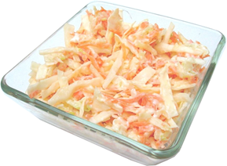
Ingredients
¼ white cabbage
Complexity: low-medium
2 x sticks celery
1 carrot
1 x 15ml spoon of low fat mayonnaise
1 x 15ml spoon of plain yogurt.

Equipment
Chopping board, sharp knife - for adult use only, kitchen scissors, vegetable peeler, grater, mixing bowl, a 15ml spoon.

Method
- Remove the core from the cabbage.
- Separate the cabbage leaves and cut them into strips with the scissors.
- Top and tail the carrot, then peel and grate.
- Cut the celery lengthways and the snip or cut into small pieces.
- Place the cabbage, carrot and celery into the mixing bowl.
- Add the mayonnaise and yogurt to the other ingredients and mix together.

Top tips
- Wash all the vegetables before use.
- Instead of the yogurt, try reduced fat fromage frais or crème fraiche.
- Add other vegetables such as sweetcorn, pepper or spring onions.
- Add herbs like chives or parsley.
- Serve with a jacket potato for a tasty lunch.

Food skills
- Measure.
- Core.
- Snip.
- Cut and trim.
- Peel.
- Grate.
- Mix.

