**Brilliant bread**

**Ingredients**  
250g strong flour

**Complexity**: low-medium

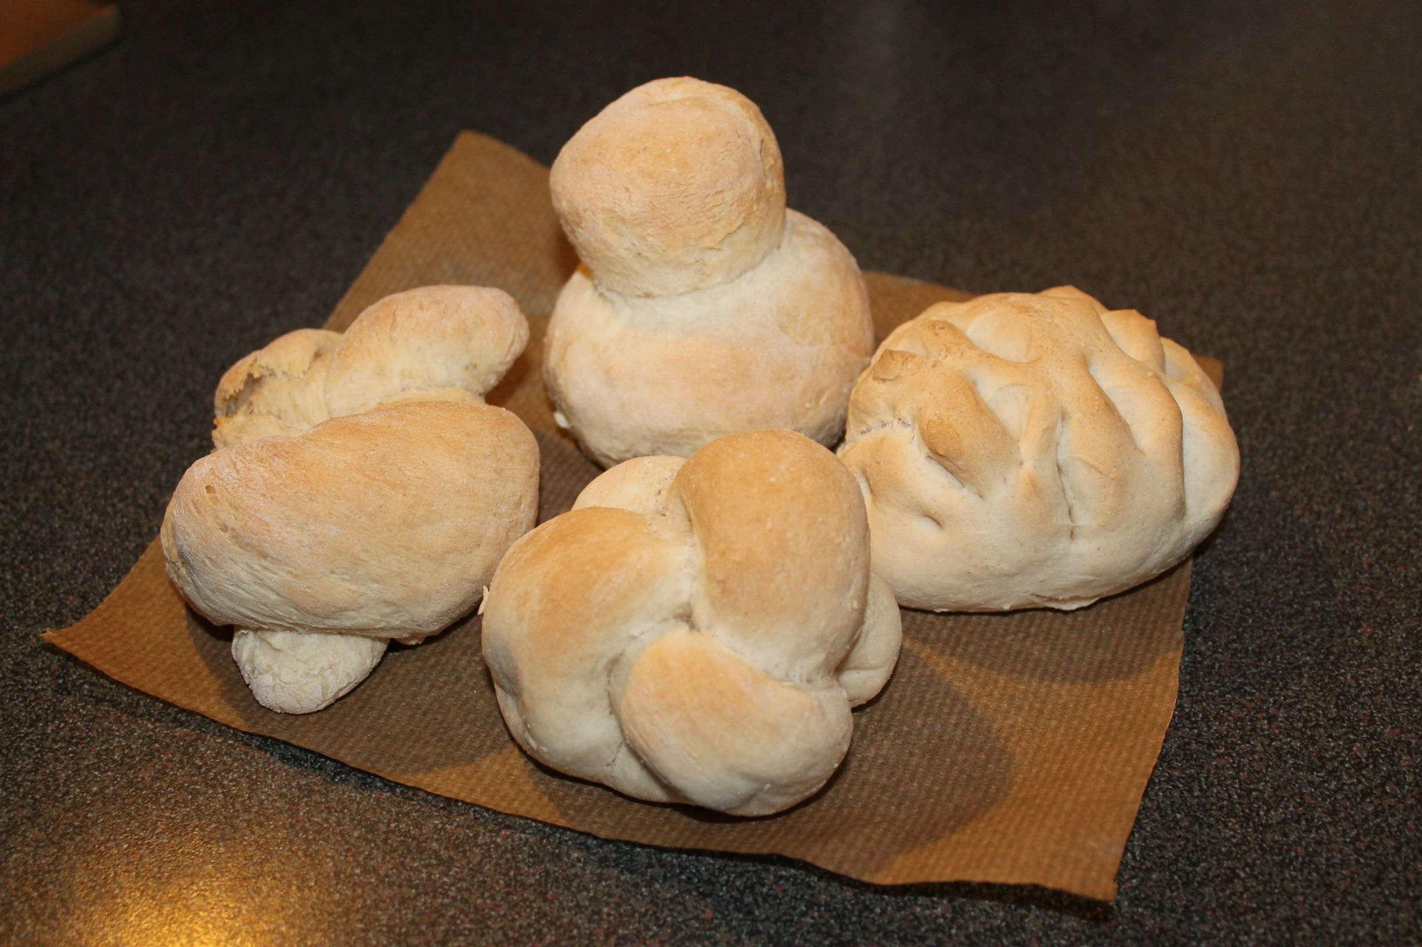1/2 x 5ml spoon salt

7g pack fast action dried yeast

150ml warm water

**Equipment**

Weighing scales, measuring spoons, measuring jug, baking tray, greaseproof paper, sieve, mixing bowl, mixing spoon, flour dredger, oven gloves, cooling rack.

**Method**

1. Preheat the oven to 220ºC or gas mark 7.
2. Line the baking tray with greaseproof paper.
3. Sift together the flour and salt into the mixing bowl.
4. Stir in the yeast.
5. Make a well in the middle of the flour mixture and add the warm water. Note: the water must not be hot. Mix to form a soft dough.
6. Sprinkle a little flour onto a clean work surface and place the dough on the surface.
7. Knead the dough for 10 minutes.
8. Divide the dough into 4 pieces and shape into rolls.
9. Place the rolls on the baking tray.
10. Cover the dough and leave to prove for 30 minutes in a warm place, until they double in size.
11. Bake for 10 - 15 minutes until golden brown. **Adults** to use the oven.

**Top tips**

* Why not try adding 25g apple, grated cheese, dried fruit or chopped onion to the flour mixture?
* Decorate your bread with grated cheese or diced onion before baking.

**Food skills**

* Weigh.
* Measure.
* Sift.
* Stir and mix.
* Knead.
* Divide and portion.
* Prove.
* Bake.