Pleasing pasta take home letter

Dear parent/carer
We have been learning about pasta. We looked at different types of pasta and talked about meals made from pasta. We also made a cold pasta salad.
Next time you go food shopping, look out for different types of pasta with your child. Become a food investigator, and see if you can spot the types of pasta below. Tick off each type when you find it.
Pasta search!

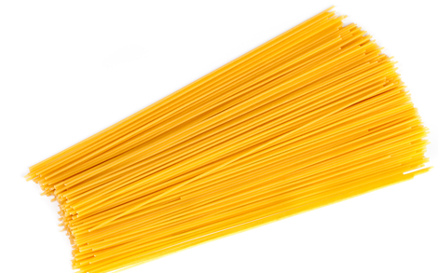
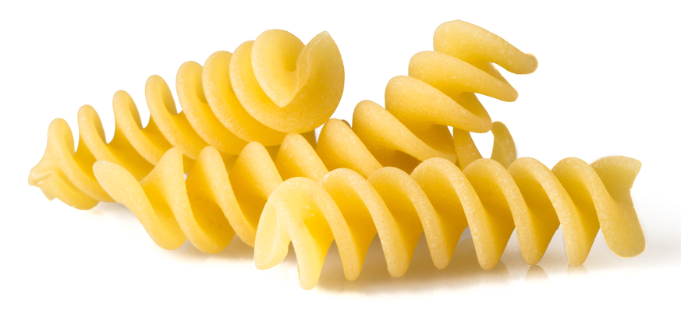

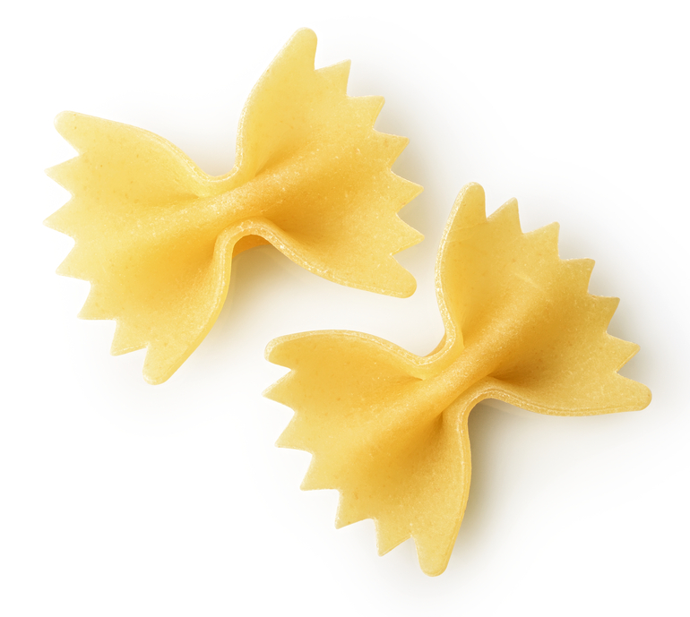
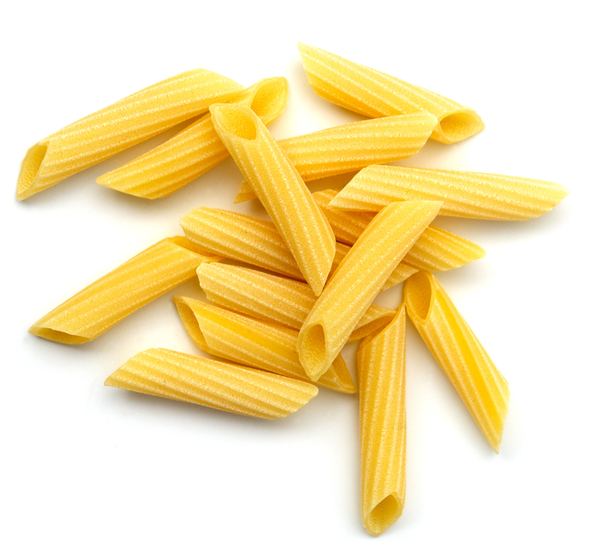
Fusilli
Spaghetti
Farfalle
Penne

