YEAR 9 THEORY –1 Impact of new & emerging technologies Name: --------------

1) Technology push is when products are re-designed because of changes in materials or manufacturing methods.

Give 2 examples of how technology-push has influenced the development of a mobile phone. (4 marks) 2 marks for a more technical explanation i.e. “development of materials (1 mark) with introduction of conductive plastic and touch screen (1 mark)
Analogue to digital
Smart materials development
Data storage development
Battery development
Developments in material
Developments is manufacture
s

2) The Product Life Cycle below shows the sales of laptops at each stage throughout its life cycle.
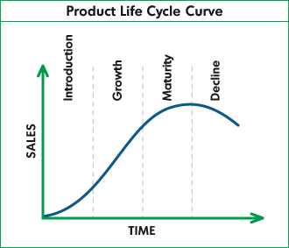

- Describe what happens during the Growth stage of the product. (2 marks)
Growth- advertising takes effect, sales rise, company make profit, competitors may introduce own brand

- Give a reason why product obsolescence might occur. (1 mark)
New technologies may push this (new, more improved material, electronics etc.)
It could be a product that people no longer want to buy (like a fad (fidget spinners/loom bands)
No longer profitable to company.
Company launch a new product onto market, so stop manufacturing old one.

- What can businesses do to try and extend a products life cycle? (2 marks)
Advertise, reduce price, new packaging, add value to the product (i.e. add a new feature)

- Fill in the blanks to the sentence below. (1 mark)
JIT
- Just-in- time manufacturing is when materials/components are ordered so they arrive just as they are needed

- Give an advantage of JIT to a manufacturer. (1 mark)
The company does not have to pay for large amounts of stock in one go.
Saves on space for storage
The company is less likely to be left with lots of unsold stock.

- What is the name for the symbol below? (1 mark)
Kite mark
---------------------------------------------

- The “Consumer Rights Act” gives consumers a number of rights to protect them when buying products.
A products quality must meet 3 requirements, can you give one of these requirements? (1 mark)
Satisfactory quality
Fit for purpose
As described

- There are many moral and ethical factors related to the manufacture and use of products.

Name one moral/ethical reason why the manufacture or use of a mobile phone can have a negative effect. (2 marks)
Driving distractions
Working conditions
Toxic chemicals
Privacy and pictures
Minerals used in mobile phones (child labour & wildlife destruction)

- CAD (computer aided design) and CAM (computer aided manufacture) are widely used in industry.
Fill in the table below, giving the advantages and disadvantages for both. (4 marks)

 | Advantage | Disadvantage
CAD | See mind map given
CAM

- CNC is a term used in manufacture. Complete the blank below (1 mark)
Computer – numerically –controlled

9) Many different types of CAM machinery is used in the manufacture of products, including a “CNC Router”
Describe what a “CNC Router” does. (1 mark)
Cutting machine used for cutting & engraving various hard materials. It is able to engrave in 3D.

What products is it commonly used for? (1 mark)
Door carvings, furniture, musical instruments,

Total marks= your mark /22 Percentage= Grade

