Investigating Flower Structure and Function in Primulas
Student Support Sheet

Charles Darwin was fascinated by the complex structure of primula flowers. In his autobiography, he wrote "I do not think anything in my scientific life has given me so much satisfaction as making out the meaning of the structure of heterostylous flowers." Some 150 years after Darwin did his research on these intriguing flowers, they continue to enable scientific insights.

The ability to accurately observe, dissect and record an organism is a key skill for biology students. It was Darwin’s skill at observation and ability to reflect on what he saw that enabled him to make his own breakthroughs.

In this activity, you will focus on a flower, a plant reproductive organ that is adapted for pollination. You will then reflect on what modern understandings of genetics has to tell us about the observations you make.

Generalised structure of a flower

Task 1.
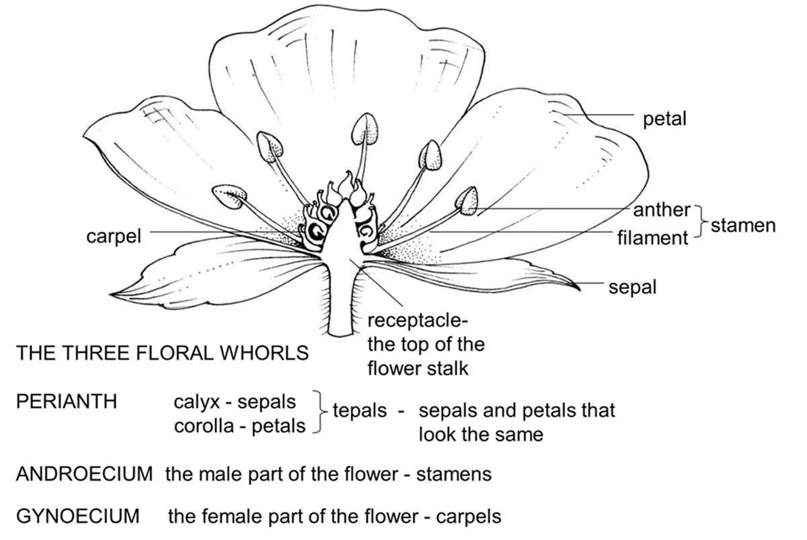
Label the parts of a flower

Task 2 - Scientific drawing errors.

Here is a correctly-drawn scientific drawing of a Primula flower.
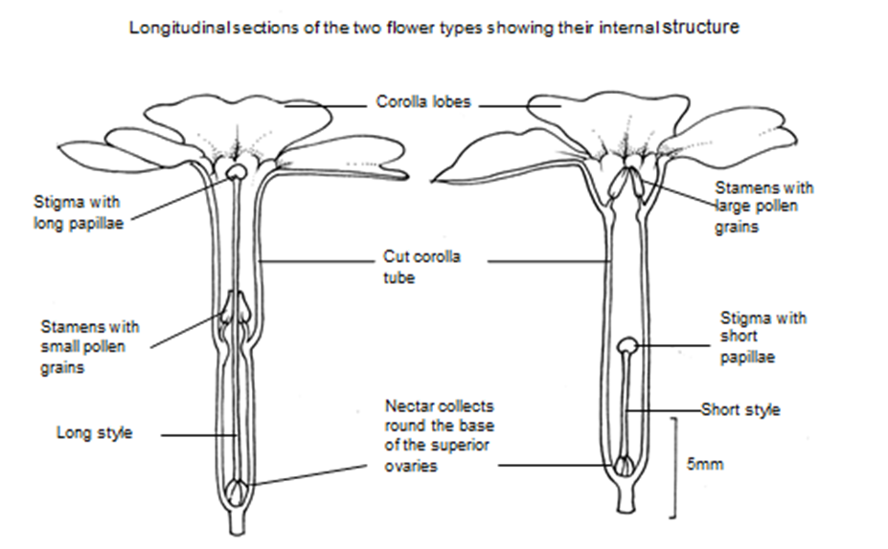

Use the scientific drawing above to help you to identify the errors in the drawing below. Circle each error on the drawing and add a clear label to explain what the error is.
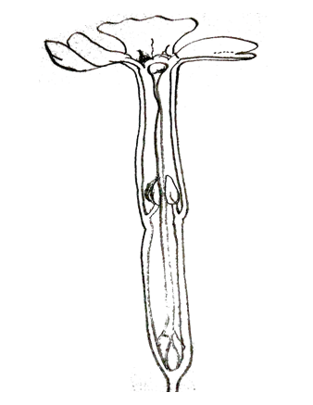

Task 3

When you have completed your dissection, read the Primula fact file below and answer the questions. As you read the fact file, use an intact flower, your dissected flower and your scientific drawings to help you to understand the adaptations shown by the Primula flower to its function.

Fact File - Primrose (Primula vulgaris)

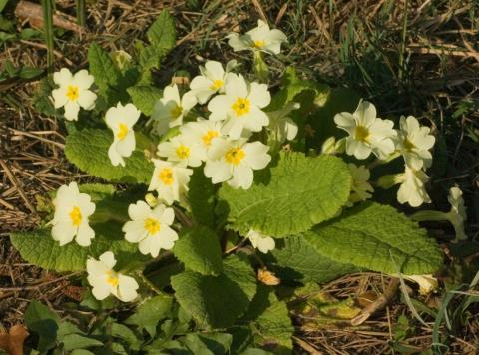
Primroses growing in a woodland habitat

Name
The common name is derived from the French name ‘Primevere’ derived from the Latin for first, primus and verna meaning spring.

Classification and distribution
The Primrose Family Primulaceae is predominantly a northern temperate family

Economic use
The genus Primula, and two other genera, Cyclamen and Lysimachia, are important horticultural plants.

Flower structure
Symmetry | Radially symmetrical (actinomorphic)
Perianth | Calyx – 5-toothed,formed of 5 fused sepals
Perianth | Corolla – 5 fused yellow petals. A long corolla tube opens out into 5 showy lobes.
Androecium | 5 stamens attached to the corolla
Gynoecium | 5 fused carpels. Ovary superior with 1 chamber. The ovules are arranged around a single central placenta – free central placentation.

Flower morphology and pollination
The flowers are insect-pollinated by long-tongued insects such as Bee-flies (Bombylidae) or spring-flying moths.

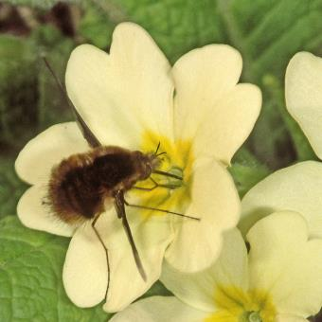

A Bee-fly (Bombylius sp.) visiting a pin-eyed Primrose flower.

The Primrose has two sorts of flower, pin-eyed and thrum-eyed.

Pin-eyed Primrose Thrum-eyed Primrose
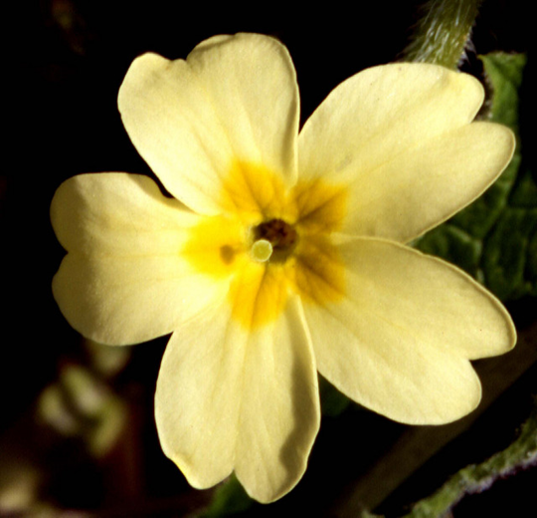
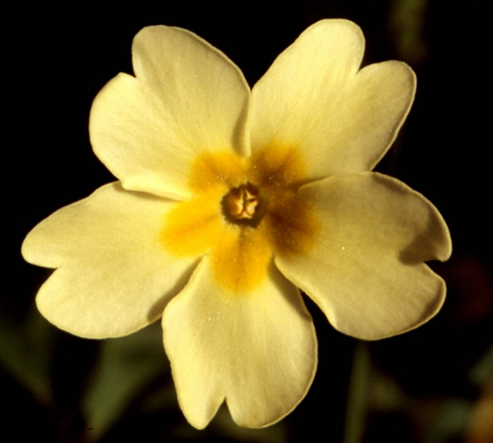

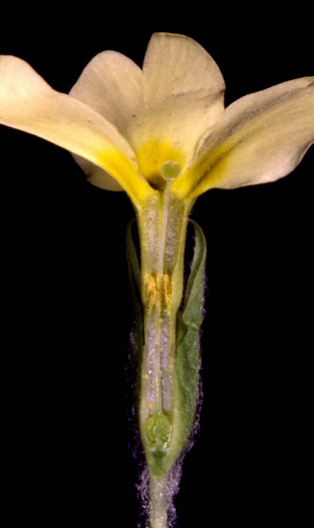
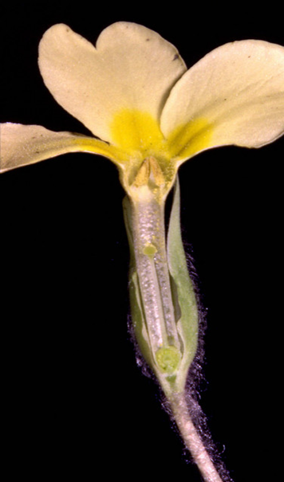
Longitudinal section through
a pin-eyed Primrose
Longitudinal section through
a thrum-eyed Primrose

When an insect visits a pin-eyed flower, its proboscis (tongue) acquires pollen from the stamens half-way down the flower tube. This position of the pollen on the insect’s tongue makes it more likely to be deposited on the stigma when the insect visits a thrum-eyed flower. In the same way, pollen collected from a thrum-eyed flower is in a position suited to be deposited on the stigma in a pin-eyed flower. About half the flowers in a population of Primroses will be thrum and half pin.

Successful pollination and fertilisation relies on the pollen being ‘accepted’ by the stigma and producing a tube which grows down the style into the ovary. Most species which have more than one flower type also have a self-incompatibility mechanism. The photographs show that in the primrose there is a mismatch in the size of the pollen grains and the stigmatic papillae (projections on the surface of the stigma). This may well limit self-fertilisation.at least in the thrum flowers where the large pollen grains produce a tube too large to penetrate the surface of the thrum stigma. It is also likely that if the small ‘pin’ pollen grains are transferred to the pin stigma they do not contain enough food reserves to allow them to grow all the way down the long pin style to the ovary.

Pin stigma (top) and pollen (bottom) Thrum stigma (top) and pollen (bottom)
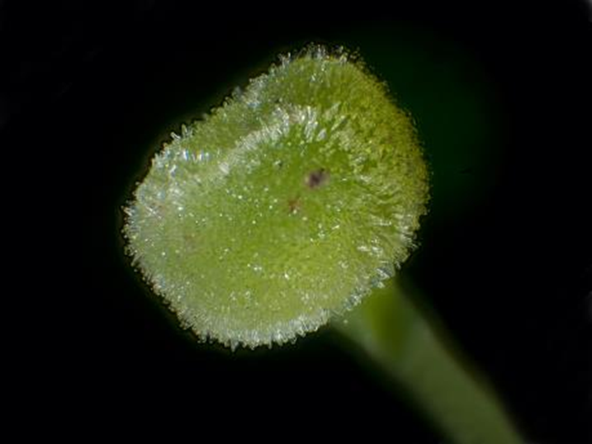
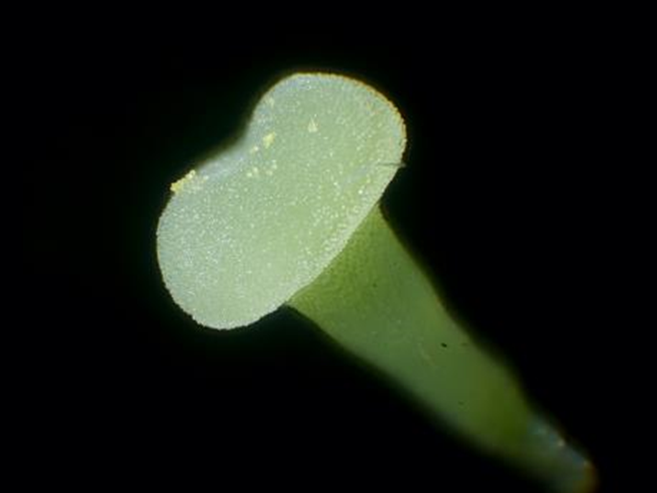

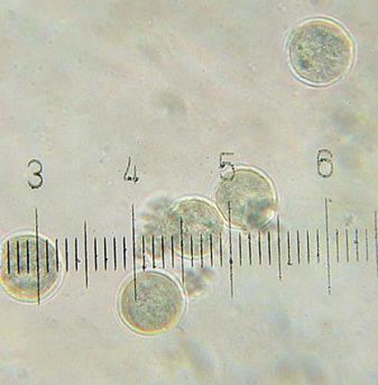
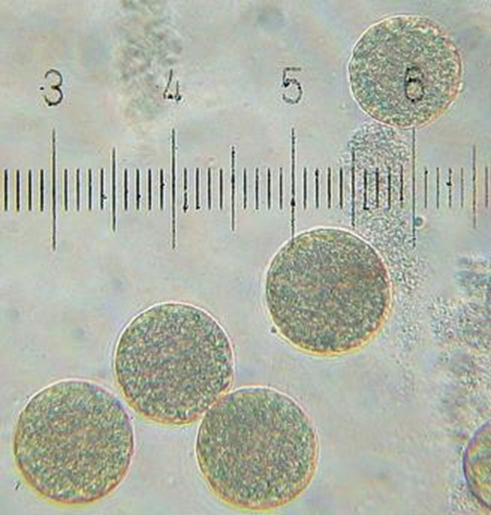

Questions
- What is the function of the Primula flower?
- Which organisms are the pollinators of Primula in its native habitat?
- About half the plants in a population of Primroses will produce pin-eyed flowers and half will produce thrum-eyed flowers. Use your knowledge of the structure of primula flowers and information in the passage to explain how the presence of the two flower types within a Primula population ensure cross pollination.
- The genes responsible for pin-eyed and thrum-eyed Primula flowers are found on a part of the Primula genome called the S locus. Pin-eyed flowers have a homozygous recessive genotype, while thrum-eyed flowers are heterozygous at the S locus.
- (i)Use a punnet square to show the genotypes and phenotypic ratios that will arise from a genetic cross between a pin-eyed and a thrum-eyed flower.
(ii)Does the result of this genetic cross agree with the phenotypic ratios observed in populations of primrose plants?
- Explain why it is unlikely that populations of primrose plants will contain plants with the homozygous dominant genotype.

Suggestions for further reading
Charles Darwin was fascinated by the ‘heterostyly’ that he observed in Primrose flowers. You can learn more about his pioneering observations here: ‘On the Two Forms, or Dimorphic Condition, in the Species of Primula, and on their remarkable Sexual Relations’, in John van Wyhe, editor. 2002-. The Complete Work of Charles Darwin Online. http://darwin-online.org.uk/converted/published/1862_primula_F1717.html
Research continues into the genetic control of flower morphology in the Primrose. You can read a commentary on a recent research paper that has identified the role of one of the genes responsible, here: Plant reproduction: Long story short, John R Pannell Guillaume Cossard, eLife 2016;5:e20314, https://elifesciences.org/content/5/e20314

