|  |  |  |  |  |  |  |
| --- | --- | --- | --- | --- | --- | --- |
| Natural timber –two types. | | | | | | |
| Image result for leaves falling from tree animated clip artImage result for leaves  clear backgroundHard woods  COME FROM ***-------------------------*** TREES & ----------------------------------  DECIDUOUS TREES **-------------------------------------------------------------------------------------------------------------------------** | | | | Image result for PINE TREE ANIMATED CLIP ARTImage result for pine needles clear backgroundImage result for pine cone clear backgroundSoft woods  COME FROM ***----------------***TREES & --------------------------  EVERGREEN ---------------------------------------------------------------------------------------------------------------------------------- | | |
| Softwoods are less expensive than hardwoods due to **-----------------------------------------** | | | | | | |
| Pine | | Cedar | | | Fir | |
| Colour | | Colour | | | Colour | |
| Strength | | Strength | | | Strength | |
| Use | | Use | | | Use | |
| Hardwoods are more expensive due to **-----------------------------** and **--------------------------------------** | | | | | | |
| **BEECH** | **ASH** | | **OAK** | | | **MAHOGANY** |
| Appearance  This wood has a very ***-------------------------------------*** which is **------------ -------------------------------------------** in colour | Appearance  The timber has a **----------- ---------------------------------** it is *-----------------------* | | Appearance  **-------------------------------------**. It has an *-----------------------------* | | | Appearance  Has a ----------------------------------------- *interlocking grain.* |
| Strength  ***------------------*** but is also very ***----------------------------------*** It does warp very easily. | Strength  The wood  is ***------------*** but ***----------------*** | | Strength  The timber is very *-----------------------------------------------------* | | | Strength  It is ***-----------------------------*** but ***---------------------------*** |
| Uses | Uses | | Uses | | | Uses |



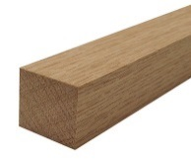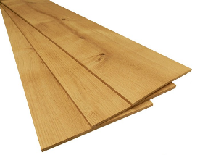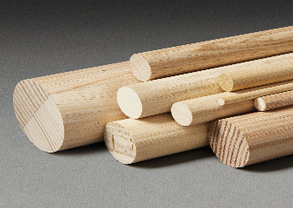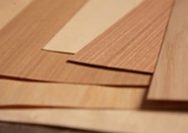

**Manufactured boards**

Manufactured boards are timber sheets which are **-------------------------------------- -----------------------------.** Manufactured boards often make use **------------------------------------------**

Manufactured wood properties.

* Make use of -----------------------------------------i.e. --------------------------------------
* Are ------------------------so are often used ----------------------------------------
* However -------------------------------------------------------------------------------
* Often ------------------with a -----------------------------------------which is called a -----------

this ----------------------- their ------------------------------

|  |  |  |
| --- | --- | --- |
| Wood | Description | Uses |
| **MDF** | Smooth, **--------------**. Easily **----------------------**------------------------------------------------- | **------------------** and**--------------------**Often **--------------------------------** or **----------------** |
| **Plywood** | A very strong board which is constructed of**----------------** which are glued at **------------** to each other. | Strong board used in **--------------------------------------------------------------------------------------------** |
| **Chipboard** | Made from **------------------ ----------------------** Usually **------------------** or covered in **--------------------------- -------------------** | Used for **---------------- ------------------------------------** usually **-------------------------------------------------** with a plastic laminated. |
| **Hardboard** | A **--------------** particle board which sometimes has **------------------------------------------------** | Used for **--------------------------** covering **-------------** structures, **------------------------** |

Finishing an protecting wood

|  |  |  |  |  |  |
| --- | --- | --- | --- | --- | --- |
|  |  |  |  |  |  |

Function/Purposes