YEAR 9 THEORY –3 Modern and Smart materials. Name: ------------------------

1. This power drill is made using QTC (Quantum Tunnelling composite) Analyse why this material is a particular suitable material for the power drill (3 marks)

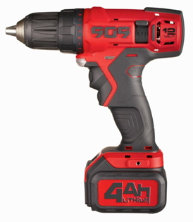

---------------------------------------------------------------------------------------------------

---------------------------------------------------------------------------------------------------

--------------------------------------------------------------------------------------------------

--------------------------------------------------------------------------------------------------

-------------------------------------------------------------------------------------------------

-------------------------------------------------------------------------------------------------

1. Fill in the blanks below. (4 marks)

SMA stands for shape ----------------- alloy. It is special because -------------------------------------------------------------------------

----------------------------------------------------------------------------------------------------------------------------------------------------------

---------------------------------------------------------------------------------------------------------------------------------------------------------

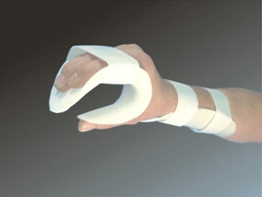

|  |
| --- |
| 1. Polymorph is often used to make prototypes to solve manufacturing problems. Evaluate why polymorph is a suitable material for this. (3 marks) |
|  |
|  |
|  |
|  |

----------------------------------------------------------------------------------------------------------------------

1. Microencapsulation is when microscopic bubbles are filled with a substance and then sprayed onto fabrics. Name 2 possible substances that the bubbles could be filled with. (2 marks)

----------------------------------------------------------- -----------------------------------------------------------------------

1. Tick true or false for each statement. (3 marks)

|  |  |  |
| --- | --- | --- |
| Statement | True | False |
| Photo chromatic dyes change colourin response to UV light/sunlight. |  |  |
| Thermochromic dyes change colour in response to UV light/sunlight |  |  |
| Biometrics identifies an individual from a physical characteristic |  |  |

1. Write the most appropriate material for each of the products shown below. (3 marks)

Carbon fibre

LCD

GRP

Kevlar

Nomex

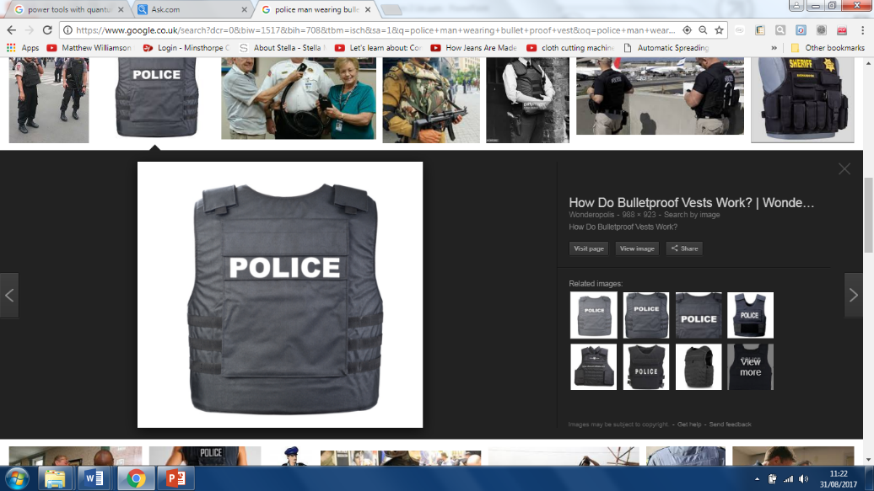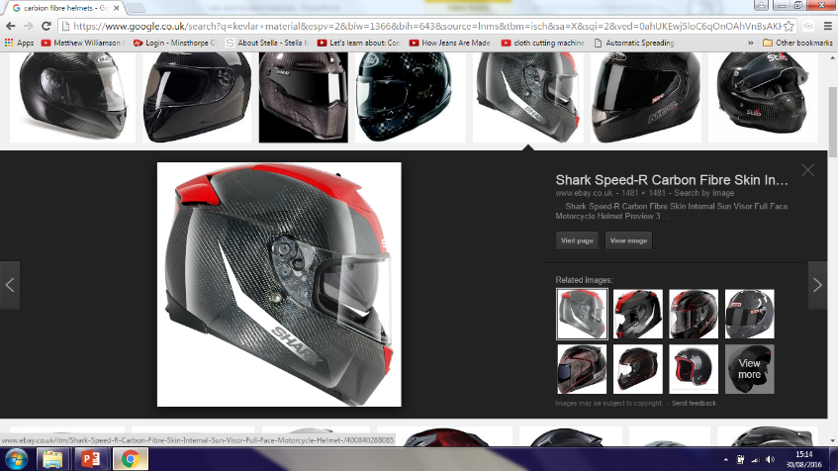

1. 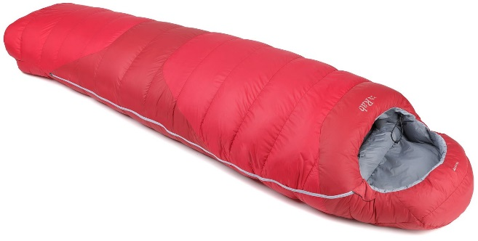The sleeping bag pictured is made from “phase changing materials. Analyse why the material properties of phase changing materials make it a particularly suitable material for the sleeping bag. (3 marks)

------------------------------------------------------------------------------------

------------------------------------------------------------------------------------

------------------------------------------------------------------------------------

------------------------------------------------------------------------------------

------------------------------------------------------------------------------------

-------------------------------------------------------------------------------------

1. Fill in the blanks below (3 marks)

GRP stands for ------------------- reinforced -------------------------------

LCD stands for Liquid --------------------- display.

1. Geotextiles is used in civil engineering, for construction work in building roads, dams and canals. Give two reasons why geotextile materials are important and suitable for such use. (2 marks)

------------------------------------------------------------------------ ------------------------------------------------------------------

Total marks= your mark / 26 Percentage= Grade=