YEAR 9 THEORY –3 Modern and Smart materials. Name: ------------------------

- This power drill is made using QTC (Quantum Tunnelling composite) Analyse why this material is a particular suitable material for the power drill (3 marks)
Electrically conductive material
Material is a pressure switching and sensing material technology.
Speed control/variable speed control
Sensitive to pressure and lightweight- when pressure is applied the material becomes a conductor (allows elect city to flow, which allow user to control the speed.

- Fill in the blanks below. (4 marks)

SMA stands for shape memory alloy. It is special because when bent out of shape, can be heated above a certain temperature it will return to its original shape.

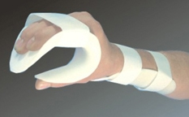
- Polymorph is often used to make prototypes to solve manufacturing problems. Evaluate why polymorph is a suitable material for this. (3 marks)
Easily mouldable, can be re-heated and re-used. Can easily be shaped into awkward and unique shapes. Tough material, yet once heated can be easily shaped.

- Microencapsulation is when microscopic bubbles are filled with a substance and then sprayed onto fabrics. Name 2 possible substances that the bubbles could be filled with. (2 marks)
Fragrances (perfume) Insect replant
Vitamins moisturisers.
Anti-bacteria substance.

- Tick true or false for each statement. (3 marks)
Statement | True | False
Photo chromatic dyes change colour in response to UV light/sunlight. | x
Thermochromic dyes change colour in response to UV light/sunlight |  | x
Biometrics identifies an individual from a physical characteristic | x

- The most appropriate material for each of the products shown below. (3 marks)
Carbon fibre
LCD
GRP
Kevlar
Nomex

GRP
Carbon fibre
Kevlar

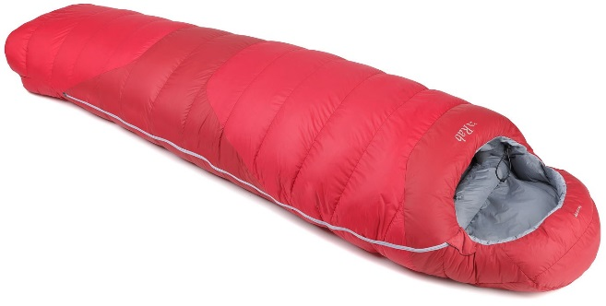
- The sleeping bag pictured is made from “phase changing materials. Analyse why the material properties of phase changing materials make it a particularly suitable material for the sleeping bag. (3 marks)
When you get too warm, the material absorbs and stores the excess heat. When you cool down the heat is released back to the body.

Basic answer- helps to maintain constant body temperature.

- Fill in the blanks below (3 marks)

GRP stands for Glass reinforced plastic
LCD stands for Liquid crystal display.

- Geotextiles is used in civil engineering, for construction work in building roads, dams and canals. Give two reasons why geotextile materials are important and suitable for such use. (2 marks)
Permeable, absorbent, can separate, filter, reinforce, protect and drain.
Can be used to strengthen and protect from erosion

Total marks= your mark / 26 Percentage= Grade=

