QTC (Quantum Tunnelling composite)

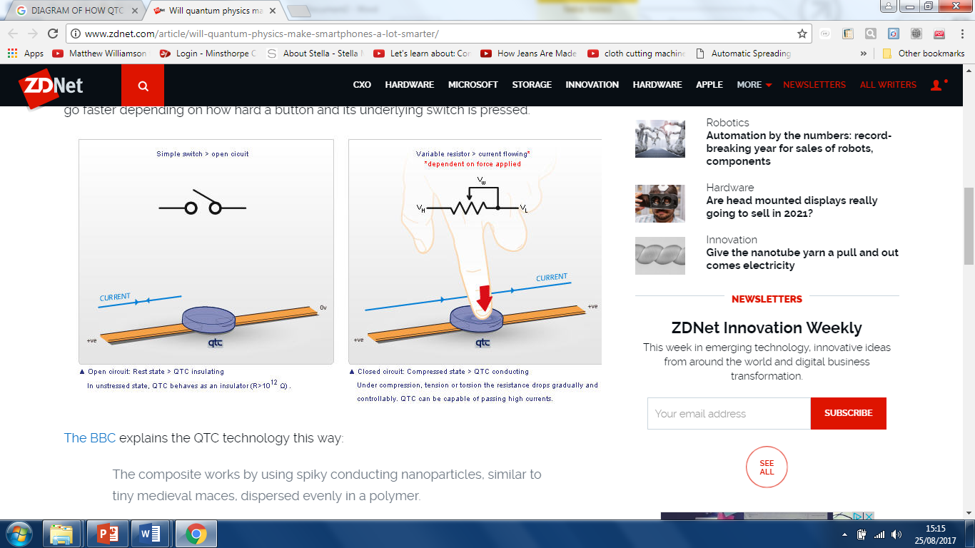

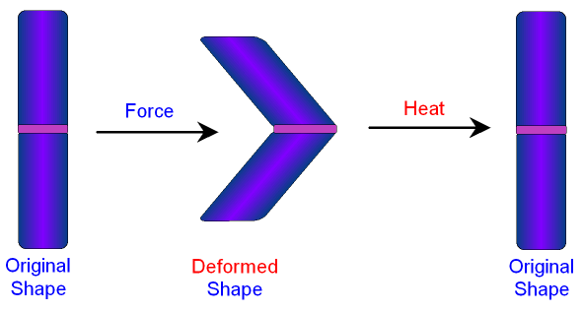

SMA (Shape memory alloys)

WWWW

When bent out of shape, can be -------- above a certain temperature it will return to it’s ----------- ------------.

It is normally an ----------------- (does not conduct electricity) but if pressure is applied it becomes a ---------------- (allows electricity to flow)

---------------------------------------------------------------------------------------------------------------------

An ------ (mix of two or more --------)

-------------------------------------------

--------------------------------------------

It’s a flexible ---------- that contains tiny ------- particles

QTC can be made ----------this means it’s very sensitive to --------------It’s very ------------------

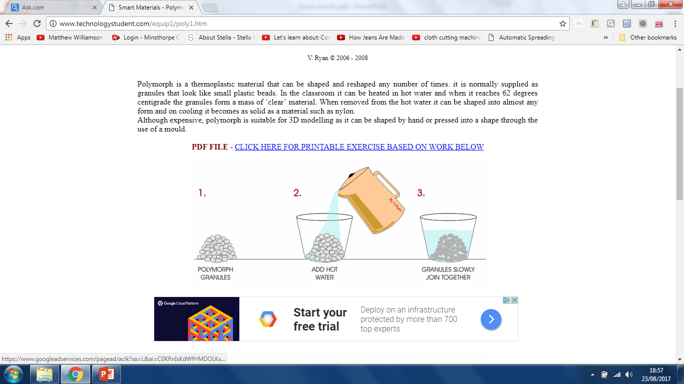

Biometrics

Polymorph

The material can “--------------” two distinct shapes, a ------ temperature shape and a -----temperature shape.

It is a -------- material yet becomes easily ------------ at 62°C.

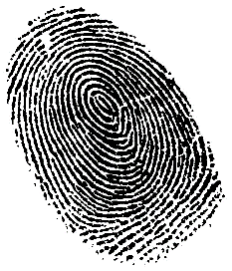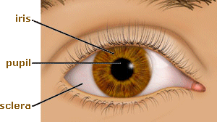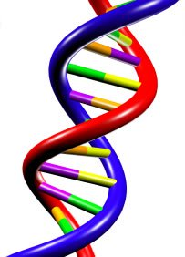

Biometrics identifies an ------------ from a --------- -------------------

---------------------------------------------------------------------------------------------------------

---------------------------------------------------------------------------------------------------------------------------

Small pellets which ------ together when heated to ----

Form of -----------and -----------------

Since biometric identifiers are -------- to individuals, they are more -------------

Once cooled, hardens like a -------------

Can be re----------to create new and unique shapes.

Photochromic dyes

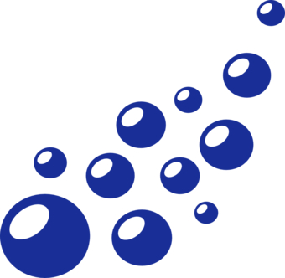

Microencapsulation

Photo chromatic dyes change -------- in response to --------------------------

When they come into contact with skin, they ---------- and slowly

----------- the substance.

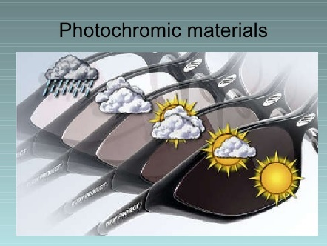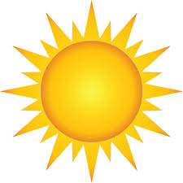

---------------------------------------------------------------------------------------

----------------------------------------------------------------------------------------------------

Tiny microscopic

--------- filled with a ------------ that are sprayed onto the material.

It is a smart -----that can be added to plastics and fabrics.

They can be filled with:

-------------------------------------------------------------------------------------------------------------------------------------------------------------------------------------

Glasses- Reduce -------------------

and provide protection against ------------------------------------

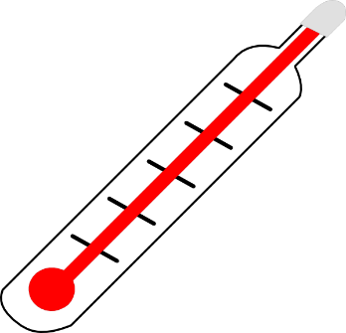

Can be used to ----------- show if something is too ---------or too ----------

Clothing- Fun and u---------------

It is a smart -----that can be added to plastics and fabrics.

--------------------------------------------------------------------------------------------------------------

Thermochromic dyes change--------- in response to changes in ------------

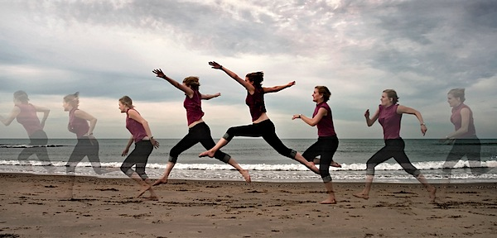

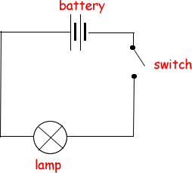

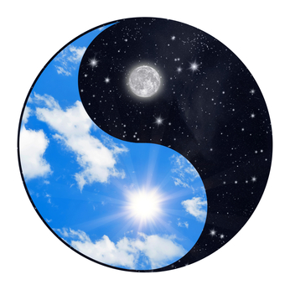

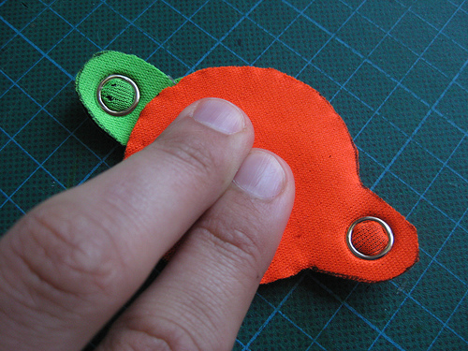

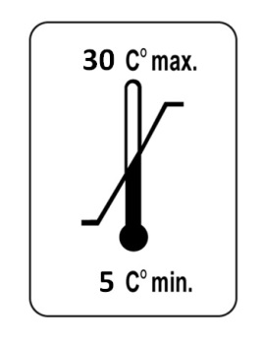

**Smart materials**

**SMART** materials are materials that respond ----------------to their changing --------------------

POSSIBLE CHANGES

* -------------------------------------
* --------------------------------------
* -------------------------------------
* -------------------------------------
* --------------------------------------

Thermochromic dyes. dyes