YEAR 9 THEORY –2 Ethics and the environment. Name: --------------

1. What are the 5 stages of a LCA (Life cycle analysis)? (5 marks)

Materials Production Distribution Use Disposal

1. Select one of the stages of a LCA and explain how a product of your choice effects the environment. (2 marks) 1 mark for basic answer- i.e. Some Materials for a mobile are toxic/if not re-cycled end up in landfill.

2 marks for a more developed answer i.e. minerals like coltan are found in countries like Africa, which cause habitat destruction/finished products are transported around the world in ships and lorries, All of these forms of transportation burn fossil fuels, which can contribute to global climate change.

1. The 6R’s are an important checklist. They are used by designers to reduce the environmental impact of products. Complete the table below. (5 marks)

|  |  |
| --- | --- |
| 6R | Meaning |
| Re-cycle | Reprocess a material or product and make something else |
| Reuse | Use a product to make something else with parts or all of it. |
| Repair | When a product breaks or doesn’t work, try to fix it. |
| Rethink | Design in a way that considers people and the environment. |
| Reduce | Cut down on the amount of material and energy you use as possible. |
| Refuse | Don’t buy a product if you don’t need it or it’s bad for the environment. |

1. Explain what the term “Sustainable design” means (3 marks)

To create products and services that are not harmful to the environment or use up the planets natural resources.

1. What does it mean if a product is “Fair trade”? (2 marks)

Ensuring that the people that make products are paid a fair price (1 mark) and have decent working conditions. (1 mark)

1. Wind is an example of renewable, natural energy. Give another 2 examples of alternative natural energy sources. (2 marks)

Sun, water, human energy, geothermal (not covered but may know from science lessons)

1. It’s important that designers and manufactures consider the welfare of people and protect them from harm. Evaluate how products can have a negative impact on people. (6 marks)

1-2 marks- have a basic understanding of how design and manufacture can affect people

3-4 marks- have a good understanding of how design and manufacture can affect people

5-6marks- Have an excellent understanding of how design and manufacture can affect people

Answer may include all or some of the following:

* Not being Fair trade- decent working conditions and fair pay.
* “Killer robotics” used in warfare.
* Anything related to cyber bullying, dark web, use of drones, hate crime.
* Use of mobile phones when driving –fatal accidents.
* Use of child workers
* Polluting Local River in poor counties, causing health problems for local people.
* Working conditions- collapsing mines, lung disease from stone washing denim.
* Camera on mobiles used to invade privacy.

1. Sustainable design is becoming increasing popular. Consider how the children’s toy car below can be re-designed to be more sustainable and reduce its impact on the environment. (3 marks)

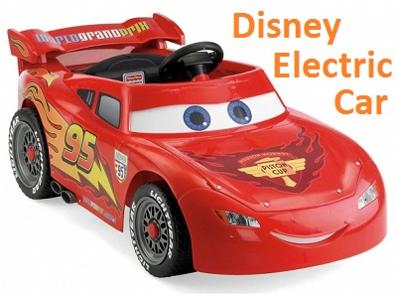

Any changes that would make the car more environmentally friendly,

Including

Source materials locally, manufacture product locally.

Reducing materials

Using re-cycled materials

Using biodegradable materials

Making it easy to repair

Making it so it’s durable (built to last)

Allow it to be powered on renewable energy (i.e. solar or human power)

Having re-chargeable batteries to reduce land fill toxins.