How much energy is used to charge it?

Is the charger left on unnecessarily?

Use

A cell phone is made up of many materials. In general, the handset consists of 40 percent metals, 40 percent plastics, and 20 percent ceramics. mat

Products require the use of packaging, to prevent spoilage and damage.

Distribution

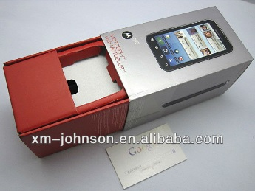

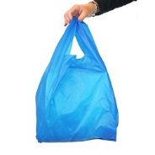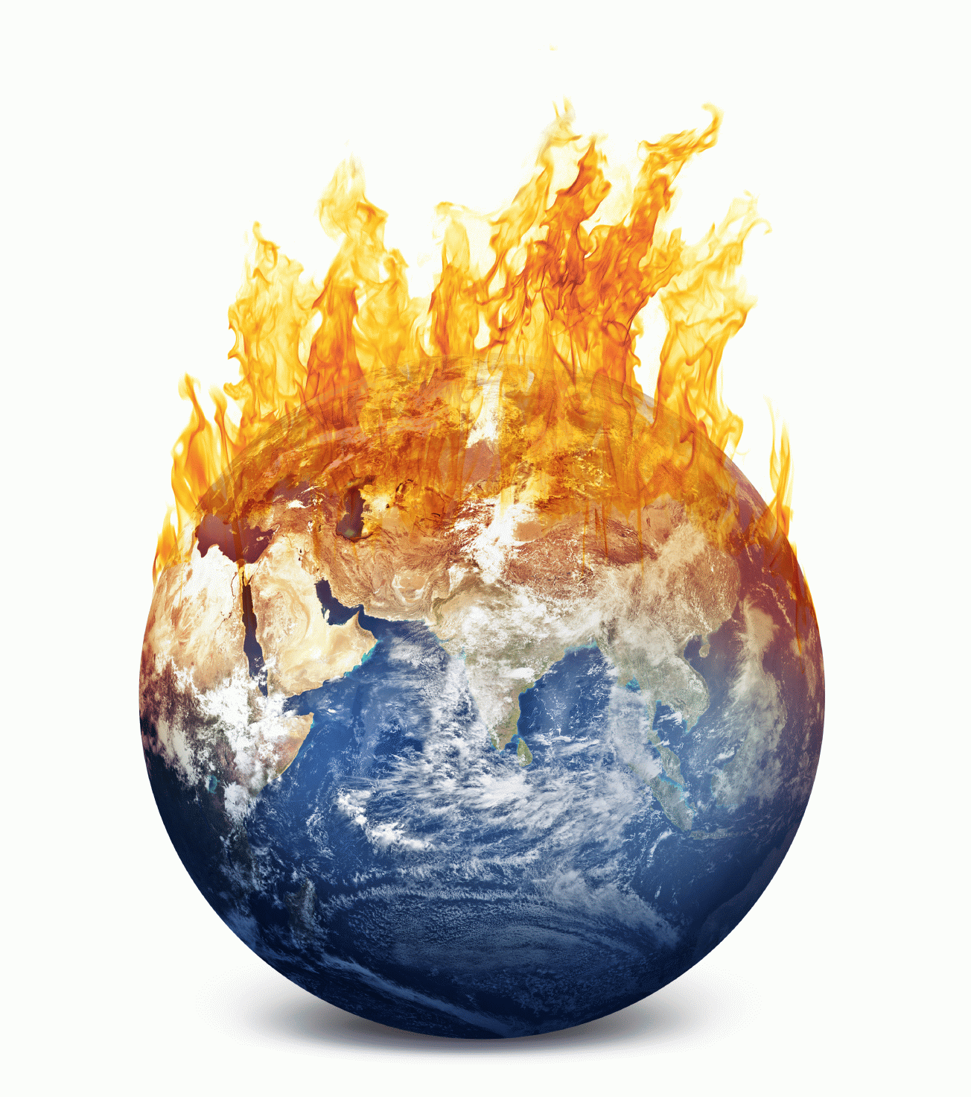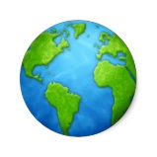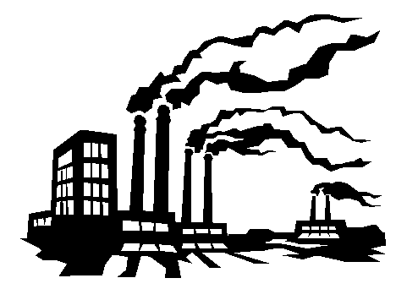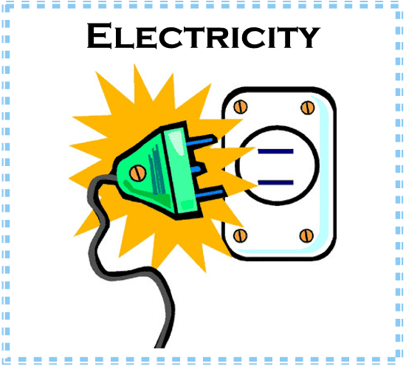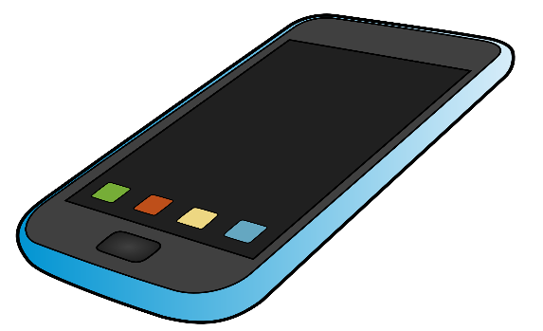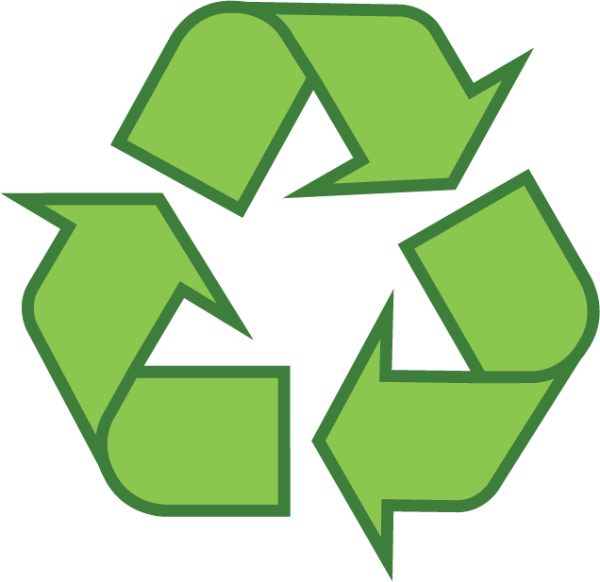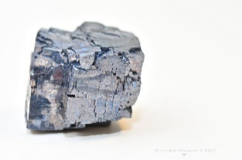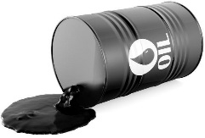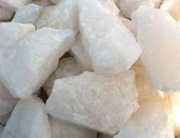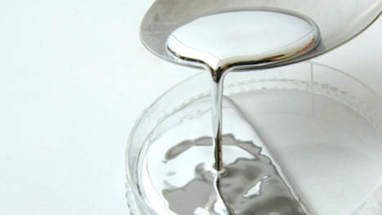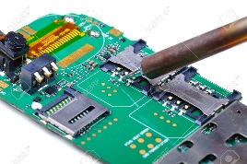 =

The “Recycling Initiative” promotes the recovery, reuse, and recycling of old electronic equipment

Disposal

Throwing a product away means that it will end up in a land-fill or incinerator and will not be useful again. Unnecessary upgrades.

Disposal

How much energy is used by different functions, e.g. use of camera (including flash), internet

use

Finished products are transported in trucks, planes, and trains to different locations where they are sold. All of these forms of transportation burn fossil fuels, which can contribute to global climate change.

Distribution

Products are made in factories and require a great deal of energy to create. The manufacturing process can also produce pollution.

Manufacture

Mercury, a potentially dangerous substance is used for the LCD screen.

Material

A mobile circuit is made from mined, raw materials including copper, gold, lead, nickel, zinc, coltan, and other metals.

Material

The manufacturing of each part is held in several different places, often at long distances from the final manufacture.

Manufacture