

Smart Cycle
Student Booklet

Contents

1. The Context 3
2. The Scenario 3
3. The Brief 4
4. Schedule for the day 5
5. Beacon design information 6
6. Beacon print information 7
7. Materials resource sheet 8
8. Account sheet 10
9. Assessment information and criteria 11

The Context

More and more people are taking to cycling for competition, personal transport and leisure. The benefits of cycling are obvious; it is enjoyable, cost effective, improves fitness and is a sustainable way to travel.

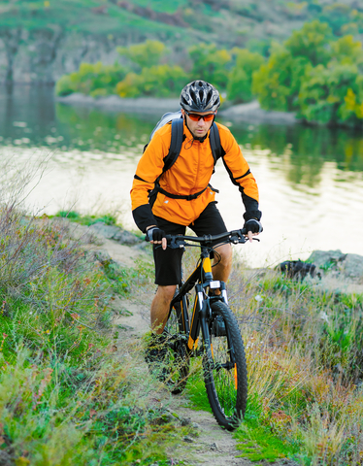

How can we improve the experience for cyclists and encourage more people to take to cycle paths this summer?

The Scenario

As the number of cyclists increases the need for better signage on cycle routes increases. Cyclists also require up-to-the-minute information about their route to improve their experience and make sure their journey is safe and enjoyable.

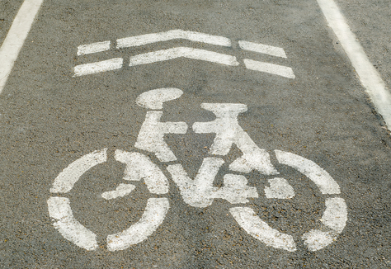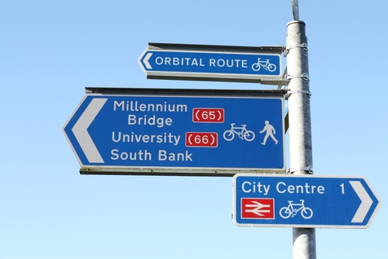

Figure 1: Current cycle route signs do not provide the information that cyclists need.

‘Smart Cycling’ is a company looking into how we can improve cycle routes throughout the UK. They have identified the need for smarter communication with cyclists along cycle routes and highlighted the need for cyclists to be able to clearly see the route markers even in the dark and to have up-to-date information about weather conditions and route conditions.

This is your chance to develop something new and make a difference…

Yes
No
Sensor
Are conditions met?
Change to system e.g. light on/off
No change to system

The Brief

You have been challenged to design and create a prototype Smart Beacon which will be used to communicate information to cyclists. When used together with other Beacons along a route, cyclists will be able to identify a safe cycling route which they can use.

Your Beacon must contain electronic components to allow it to communicate information to cyclists; this may be done by reacting to external conditions e.g. light or temperature, and then sending a signal to the cyclists who pass it on their route.

What and how your Beacon communicates is up to you. It is up to you as a team to identify which problems your Beacon will solve and then work towards designing and building a system to solve them. Will your Beacon be useful in the dark? Will it identify the cycling level of the route – easy, medium or hard? Will it communicate the length of the route? Will it communicate information about the route immediately ahead e.g. water hazard, steep hill or jump?

For your product to be the best that it can be you must be creative and innovative. Each team must:

- Identify a range of problems that cyclists encounter.
- Identify the problem that their Beacon will solve and design a solution.
- Construct the outer shell of the Beacon.
- Construct the electronics which will be housed in the Beacon.
- Demonstrate the capabilities of the Beacon by testing it in a controlled environment.

Considerations
Your Beacon must:

- Fit within the dimensions given in this brief (page 6).
- Include an electrical component.
- Communicate at least one piece of information to passing cyclists.

4. Schedule for the day

09:30 | Introduction to the Faraday Challenge Day
09:35 | Introduction to the Challenge!
09:45 | Role allocation activity
09:50 | STAGE 1: Identifying the problems and initial ideas  - Brainstorming of ideas  - Planning and research
10:05 | STAGE 2: Design and budget  - Final designs created  - Shopping list created
10.25 | STAGE 3: Development and modifications  - Shop opens  - Development and build of prototype solution
10.30 | Briefings  - 3D print engineers and designers at design station  - project managers and accountants at presentation station  - electronic engineers at presentation station
11:10 | Break
11:20 | STAGE 3 continued: Development and modifications  - Continued development and build of prototype  - Modification of prototype
12:00 | Print station opens
12:20 | Last admission to print station
12:30 | Lunch – Tools down
13:00 | STAGE 3 continued: Development and modifications  - Continued development and build of prototype electronics  - Develop presentation using laptop  - Collect printed prototype once ready and combine with electronics
13:30 | STAGE 4: Presentation  - Shop closes  - Submit accounting sheet to Faraday Challenge Leader  - Develop presentation using laptop and rehearse
14:00 | Project Manager submits presentation to Challenge Leader
14:15 | STAGE 5: Final test  - Teams present prototypes to the judges
14:50 | Award ceremony  - Final feedback and evaluation of the day  - Announcement of winning team
15:00 | Finish - Engineering teams depart

Wall thickness to be between 1 mm and 3 mm
135 mm
140 mm
140 mm

5. Beacon design information

Blueprint details
Engineers are innovative problem-solvers; they often adapt and improve on existing designs to create new products which are required to solve a current issue. To help you get started there are Beacon shell blueprints available to purchase from the shop. There are three designs – basic, standard and advanced. Each needs a different level of modification from the 3D design engineer to be suitable for your Beacon. You will need to adapt the blueprints so that your Beacon design is individual and fits the electronic components that you need to house in it. These blueprints can be found in your information booklet.

Dimensions
Your Beacon design must not be larger than the dimensions given below. If it is then it will not be able to be printed.

6. Beacon print information

3D Printing

- You will be printing your Beacon using ABS filament. As a team of engineers you will be required to pay for the material that you use and the time that you use your printer for. The material is already loaded into the printer, you do not need to buy the physical print material from the shop but you do need to pay your Faradays for the print material and time to the shop when you begin printing.

- Further information about the printer will be given to you by the Challenge Leader at the 3D design and print engineers briefing at 11.45am.

Weight of printed Beacon shell
- Engineers have to work within a specification when designing and building a new product, there is a weight limit for your beacon. Cost penalties will be issued for Beacon shells which weigh more than 20g. There will be a cost penalty of 1 Faraday for every 1g that you are over the weight limit of the Beacon.

- It is your responsibility to record the weight of the printed Beacon and the time that it takes to print in your Planning and Reflections sheet.

Breakdown of print related costs
- 10 Faradays for up to 20g of material used.
- 1 Faraday per 1g over the 20g weight limit.
- 10 Faradays per 30 minute time block of printer use.

7. Materials resource sheet
Below are the items available to buy in the shop, you have a budget of 150 Faradays.
AVAILABLE TO BUY:

Electronics options:

Item | Description | Unit | Cost
Basic electronics tool kit | Contains small screwdriver, wire strippers /cutters. | Each | 5 Faradays

Individual components:
Item | Description | Unit | Cost
Copper wire - red | Insulated wire – red. | Per 30cm | 5 Faradays
Copper wire - black | Insulated wire – black. | Per 30cm | 5 Faradays
Croc leads - black | Lead with crocodile clips at each end – black. | Each | 20 Faradays
Croc leads - red | Lead with crocodile clips at each end – red. | Each | 20 Faradays
LED bulb – single colour | Red, white and orange available. Comes with a resistor which is required in the circuit. | Each | 5 Faradays
LED bulb - flashing | Flashing LED bulb – one colour only. Comes with a resistor which is required in the circuit. | Each | 10 Faradays
Terminal blocks | Set of two terminal blocks which can be used to connect wires in a circuit. Requires a small screwdriver. | Each | 2 Faradays
Temperature sensor | Component that detects the ambient temperature and changes resistance to allow a current to flow through a circuit. | Each | 5 Faradays
Light dependent resistor | Component that detects the light level and changes resistance to allow a current to flow through a circuit when it becomes dark. | Each | 5 Faradays
Buzzers 3 Volt | Component which emits a noise when connected to an electronic circuit. Requires 2 AA batteries in a circuit. | Each | 5 Faradays
Batteries - AA size | 1.5V batteries. | Each | 2 Faradays
Battery holder – 2 x AA | Required when using 1.5V batteries. Requires 2 AA batteries. | Each | 1 Faraday
Breadboard and wire set | Small breadboard for building and testing circuits with wires – comes with instructions. | Each | 5 Faradays
Bulb 3V | Round bulb which requires 2 AA batteries in a circuit. Bulb holder required. | Each | 10 Faradays
Bulb holder | Simple bulb holder which allows bulbs to be added to a circuit. | Each | 10 Faradays
Transistor | Used to adjust the reaction of sensors in a circuit e.g. change light on when light falls on LDR to light off when light falls on LDR. | Each | 10 Faradays
Resistor | A component used in a circuit to ensure that the correct current is supplied to other electrical components in a circuit. Especially LEDs. | Each | 5 Faraday
Potential divider | Used to adjust the sensitivity of a sensor in an electrical circuit. | Each | 10 Faradays

3D design options:

Item | Unit | Cost
Basic 3D Design | 1x password to unlock file on laptop | 10 Faradays
Standard 3D Design | 1x password to unlock file on laptop | 20 Faradays
Advanced 3D Design | 1x password to unlock file on laptop | 50 Faradays

3D print material and time:
You do not need to purchase the physical items in the shop but you will need to calculate the cost of your print time and material and give this money to the shop manager.

Item | Unit | Cost
Print material | Up to 20g | 10 Faradays
Print time | 30 minutes | 10 Faradays

AVAILABLE FOR HIRE:

Item | Unit | Cost
STEM Consultant | 5 minutes | 10 Faradays

AVAILABLE ON THE LAPTOP:

Item | Description | Cost
Autodesk Inventor Professional | 3D design software. | FREE
PowerPoint | Basic software for creating a presentation. | FREE
Tutorials | Tutorial files to help you familiarise yourself with the different electronics. All tutorials can be found in the Tutorials folders on the desktop of the laptop. | FREE

8. Account sheet

Team …………………....
You will need to keep an accurate record of all the purchases your team makes and any cost penalties you incur.

Materials/resources purchased | Quantity | Cost | Faradays remaining
Print time (10F per 30 min block) | minutes
Print material | Up to 20g | 10 F
Weight penalty | g
Total Faradays remaining:

9. Assessment information and criteria

Criteria | Marks
- Planning and research | 15 marks
- Development of prototype | 10 marks
- Accounting sheet | 10 marks
- Quality of prototype | 20 marks
- Function of prototype | 20 marks
- Presentation | 20 marks
- Teamwork | 5 marks
Total | 100 marks

- Planning and research (15 marks)
Using Stage 1 of the planning sheet provided, marks will be awarded for:
- Identifying different information that cyclists need when out cycling (4 marks).
- Ideas about how to communicate different information to cyclists using a Beacon (4 marks).
- Identifying the information that your Beacon will communicate to cyclists (1 mark).
- Identify the advantages and disadvantages of your final design (2 marks).
- Recording your team’s agreed solution - include both the shell design and electrical components of your Beacon and how they work together (4 marks).

- Development of prototype (10 marks)

Using Stage 2 of the planning sheet, provided marks will be awarded for:

- Noting any changes and modifications made and the reasons for these (5 marks).
- Demonstrating the team and individual skills to persevere with challenges in developing your solution (5 marks).

- Accounting sheet (10 marks)
Use accountancy sheet (page 9) to record all of the costs the team has incurred. Marks will be awarded for:
- Accuracy of expenses – remaining Faradays matches with accountancy sheet (2 marks).
- Accuracy of expenses – shop manager records matches accountancy sheet (2 marks).
- Cost effectiveness (4 marks).
- Clarity of accounting sheet (2 marks).

If there is a tie between teams at the end of the day the winning team will be the one who has the most Faradays remaining.

4. Quality of prototype (20 marks)
Your prototype solutions will be judged on:

- Manufacture quality - How well your circuit is made (4 marks).
- Manufacture quality - How well you Beacon is designed (4 marks).
- Manufacture quality - How the Beacon and electronics fit together (4 marks).
- Creativity - designs must be innovative and creative, making best use of the resources available (4 marks).
- Demonstration of the team and individual ability to challenge themselves and push themselves to do the best that they can do to complete the challenge (4 marks).

- Function of prototype (20 marks)
- Functionality - Circuit must function effectively, easily and as planned (10 marks).
- Functionality - Beacon shell must provide a suitable housing for the electronics (10 marks).

- Presentation (20 marks)
Your presentation should communicate:

- What information your Beacon will communicate and why you chose this (2 marks).
- How your Beacon works (2 marks).
- How you would weatherproof your Beacon (1 mark).
- How you would power your beacon e.g. renewable energy, wired into the mains (1 mark).
- The STEM used in your solutions (4 marks).
- The importance of engineering to the future of cycling (1 mark).
- Honest reflection on your teamwork throughout the challenge and how the different roles have worked together (5 marks).
- The presentation skills of your team in presenting your findings (2 marks).
- Effective use of presentation software (2 marks).

- Teamwork (5 marks)
Marks are awarded for:
- How well you work as a team with all members working together effectively (3 marks).
- Ensuring that your work station and surrounding area enables safe working and are free from hazards at all times (2 marks).
Points will be deducted for not working as a safe and effective team.

