Material strength can mean many different things depending on the type of force the material is able to withstand.
Name of Force | Example Object | Sketch of Force
Tension | A shopping bag is under tension when it’s full of heavy items. | 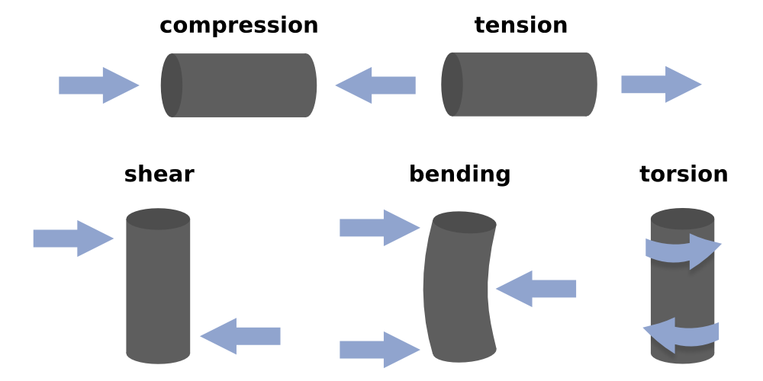
Task 1: Complete this table

Name of Force | Example Object | Sketch of Force
Tension | A shopping bag is under tension when it’s full of heavy items.
Name of Mechanical Property |  | Description
Strength |  | The ability of a material to be able to be permanently deformed.
Hardness |  | The ability of a material to resist impact.
Toughness |  | The ability of a material to stretched and then return to it’s original shape.
Malleability |  | The ability of a materials to resist a type of force such as tension, compression, torsion, shear or bending.
Elasticity |  | The ability of a material to resist being scratched or cut.
Task 2: Match the name to the description

Task 3:
Object | Mechanical Properties | Description of Forces | Sketch of Forces
Bobby pin | Elasticity | The corner of the bobby pin returns to it’s original shape once put in the hair to hold the hair in place. | 