Manufacturing and finishes Exam Style Question.

The two outdoor benches below are very similar in design however the bench in *figure 1* is made from the softwood pine and the bench in *figure 2* is made from the hardwood oak.

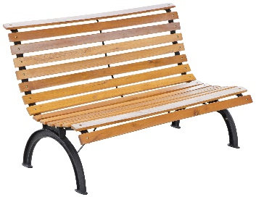 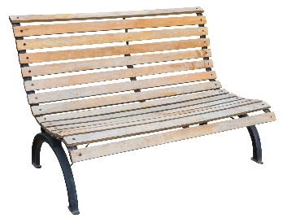

*Figure 1 Figure 2*

State **two** advantages of using pine to manufacture this bench? **[2 MARKS]**

Name **one** disadvantage of using pine. **[1 MARK]**

List **two** advantages of using oak to manufacture this bench? **[2 MARKS]**

List **one** disadvantage of using oak. **[1 MARK]**

List the types of finishes which could be applied to both benches to improve its appearance and prevent decay. **[2 MARKS]**