Manufacturing and finishes Exam Style Question.

The two outdoor benches below are very similar in design however the bench in *figure 1* is made from the softwood pine and the bench in *figure 2* is made from the hardwood oak.

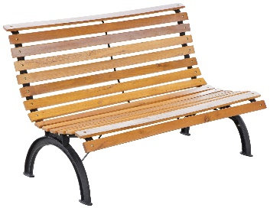 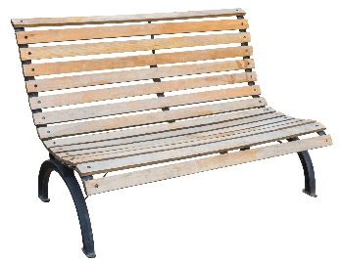

*Figure 1 Figure 2*

State **two** advantages of using pine to manufacture this bench? **[2 MARKS]**

Advantages: Low cost, readily available, can easily be stained or painted.

Name **one** disadvantage of using pine. **[1 MARK]**

Disadvantages: Must be finished to protect the timber, less robust than oak, not water resistant.

List **two** advantages of using oak to manufacture this bench? **[2 MARKS]**

Advantages: Hard wearing, aesthetically pleasing, less prone to rotting.

List **one** disadvantage of using oak. **[1 MARK]**

Disadvantages: Expensive, some types prone to splitting along grain, hardwood can blunt tools more quickly.

List the types of finishes which could be applied to both benches to improve its appearance and prevent decay. **[2 MARKS]**

Teak oil, Varnish, Danish oil, Wax