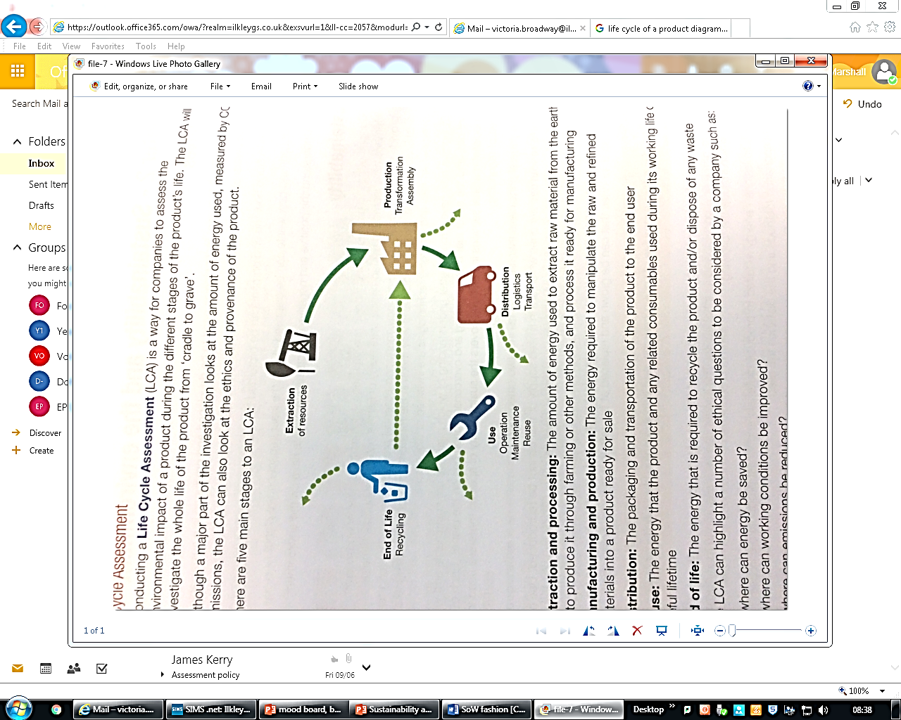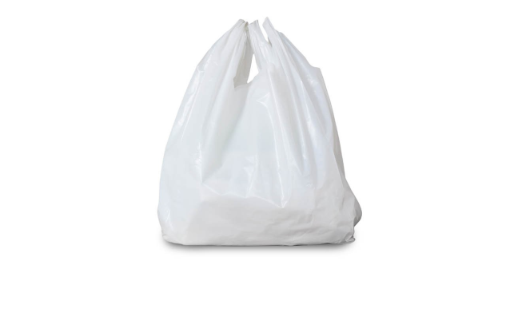**Life Cycle Assessment Question**

Use the labelled diagram below to help you conduct a Life Cycle Assessment on a plastic supermarket shopping bag.