**Key Stage 3**

**All Sorted!**

**Student worksheet**

**All Sorted!**

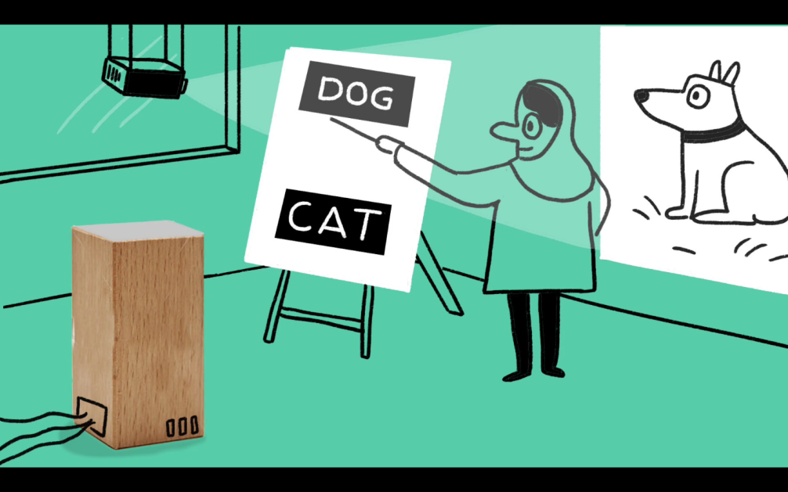

Computer algorithms often use decision trees. A decision tree is often a set of questions with yes/no answers that determine which commands the computer program runs. Each branch is the answer to a different question.

A very simple decision tree might be:

Yes

Take umbrella

**Is it raining?**

No

Leave umbrella

Decision trees can be used to sort or classify objects. If we wanted to write a decision tree to sort the following 4 objects:

(A) (B) (C) (D)

We could use the following decision tree:

(C)

Yes

Yes

**Is it white?**

(B)

No

**Does it have 3 sides?**

Yes

No

(D)

**Are all the sides the same length?**

(A)

No

There are often several different ways of creating decision trees.

***Can you think of a different way of sorting these shapes?***

**Your task – Sorting Sweets**

Put each different sweet into a box below. If you have fewer than 6 sweets you will have some spare boxes.

|  |  |  |  |  |  |
| --- | --- | --- | --- | --- | --- |
| **A** | **B** | **C** | **D** | **E** | **F** |

Create a decision tree below that will sort the sweets by asking a series of yes/no questions about the sweets until the answer is one of the sweets above. When you are finished swap your sweets and decision tree with another group and check that you get the same answers as they do. You might want to ask questions about shape/colour/number of different layers/parts etc.

|  |
| --- |
| **Your decision tree:** |