**Task A**

Draw and label a meal you have eaten today or yesterday. Which foods were on your plate?

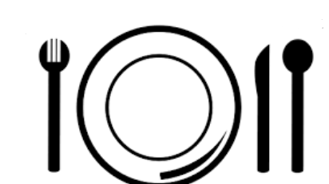

**Task B:**

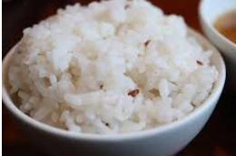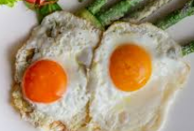Circle the foods which come from a plant:

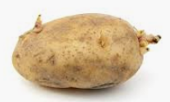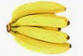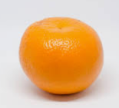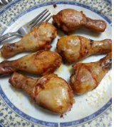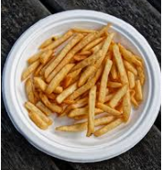 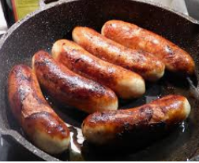

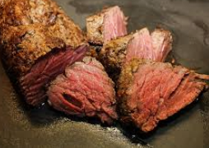

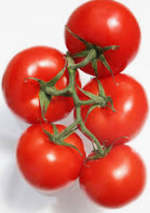



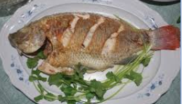

***Which foods did you find tricky to identify and why? Explain to a partner.***

***I wasn’t sure what ______ was because...***

***I knew ______ was from a plant/animal because…***

**Task C**

**Can you put these food chains back in the right order? Don’t forget your arrows!**

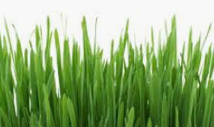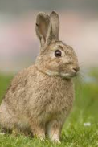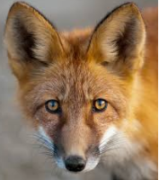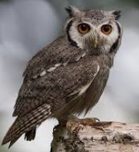

Rabbit Grass Fox

____________ _______________ _______________

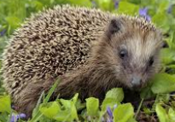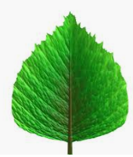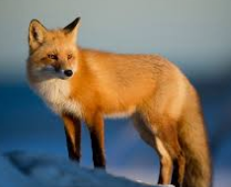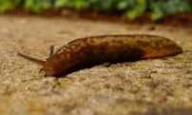

Leaf Hedgehog Fox Slug

____________ _______________ _______________ _______________

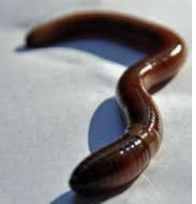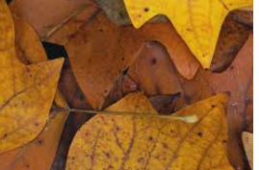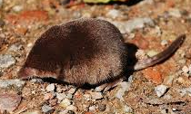

Worm Leaves Shrew Owl

____________ _______________ _______________ _______________